**COMMANDER’S REMARKS (9 May 2024)**

We will have our next staff meeting on 6 June and we will have a regular General Membership Meeting on Saturday, 15 June 2024, starting at 11:30 A.M. The meeting will be held at Las Brisas Restaurant, 6787 S. Clinton Street, Greenwood Village, CO. We will have a featured speaker. We will also conduct our election of officers for the 2024-2025 operating year. After the election, the elected officers will be installed.

To get there (Las Brisas Restaurant), if you are coming from east of I25, drive west on Arapahoe Road to South Clinton Street (about a block before you get to I25) and take a left turn. Do not turn on Clinton Court as the next street is South Clinton Street. The restaurant is located on the east side of the Target Store parking lot. If you are coming from west of I25, drive east on Arapahoe Road until you pass under I25. The first street on the right is South Clinton Street. Turn right and you will see the restaurant on the east side of the Target Store parking lot. If you get lost, you can call me at 303-981-5519 (cell) and I will try to get you un-lost.

Coy D. Ritchie, D.M.

LCDR, USN (Ret)

Denver Chapter Commander

It is nobler to serve than to be served

**STAFF MEETING (9 MAY 2024)**

This meeting was conducted at Frances Long’s home and was called to order by Chapter Commander Coy Ritchie at 1100 hours. Attending were HPM Stephanie Ritchie, HPM Pat Ritchie, and HPM Francis Long. The invocation was offered by HPM Frances Long followed by the Pledge of Allegiance.

Minutes The minutes of the staff meeting on 11 April 2024 were approved on a motion by HPM Pat Ritchie and seconded by HPM Stephanie Ritchie.

Treasurer’s Report The Treasurer’s Report as of 30 April 2024 was submitted by LCDR Ritchie. As a result of the receipt of a P & M fund distribution of $647.93, the month ended with a U.S. Bank checking fund balance of $2,787.62 and ENT Credit Union fund balance of $9091.05. The Treasurer’s Report was approved on a motion by HPM Stephanie Ritchie and seconded by HPM Pat Ritchie.

Scouts Gold Awards for the Girl Scouts have been mailed to the Girl Scout office. No names of Eagle Scout recipients have been received yet. The BSA HQ said the names would be available on 5/3/24.

ROTC/JROTC We have completed the awarding of ROTC & JROTC medals & certificates. We awarded 20

ROTC medals and 37 JROTC medals.

Patriotic Education LCDR Ritchie reported that more than 120 students have applied to be nominated to attend the RMYLC in June 24-28 at CSU Pueblo. The selection committee will select 99 to attend the YLC.

Public Safety and Law and Order Nothing new.

Region XIII and Department of the Rocky Mountains

A conference is slated for June by Zoom. The National Convention will be held in August in Valley Forge, PA. Commander Ritchie and wife Pat will attend.

Membership We have two possible contacts.

Program/Speaker We plan to have an ROTC presenter at our luncheon on 15 June.

Hospitality The next luncheon is on Saturday, June 15, 2024 at Las Brisas Restaurant. We will order from the menu.

Old Business Nothing to report.

New Business Nothing to report.

Next Staff Meeting Thursday, 6 June 2024, starting at 1100 hours at the home of HPM Frances Long.

Benediction Given by HPM Frances Long.

Adjournment LCDR Ritchie adjourned the meeting at 1152 hours.

Submitted by Adjutant HPM Frances Long



**COMING EVENTS (April & Later)**

* **STAFF MEETING (6 June 2024)**
  + (Thursday), 11:00 A.M.
  + Location: Frances Long’s Home
* **MOWW NATIONAL CONVENTION**

**(August 5-11, 2024)**

* + Location: Valley Forge, PA
* **MEMBERSHIP LUNCHEON**

**(15 June 2024)**

* + (Saturday), time 11:30 A.M.
  + Location: Las Brisas Restaurant, 6787 S. Clinton Street, Greenwood Village, CO.
  + Menu: Order from the menu.
  + Program: To be announced



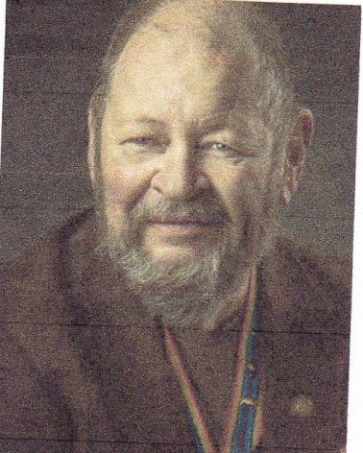

**Bob**

THE CAN AND CAN’T OF PACEMAKERS

CPT (DR) Robert E. Mallin, USA (Fmr)

Surgeon General, MOWW

When your heart has a rhythm problem, too slow, too fast, or out of sync, help is on the way from modern technology. Normal beat and good pumping are what a pacemaker is supposed to do. These devices are custom-fitted to one’s needs. The simplest one is the single-chamber pacemaker. It has one lead that connects the pulse generator to one chamber of your heart. For most people, it is connected to the right lower chamber or ventricle, or depending on the type of pacing needed, to your right atrium (upper heart chamber). More complex is the dual-chamber pacemaker with two leads connecting to both ventricular chambers and programmed to regulate the contractions of them both. That will help the two chambers work together, in the proper rhythm, so blood flows properly from one to the other. Even more advanced is the biventricular pacemaker, also known as a cardiac resynchronization therapy (CRT) device. These have three leads and are connected to the right atrium and both ventricles. It helps treat people with arrhythmias caused by advanced heart failure where the left and right ventricles do not pump at the same time, or they do not pump in synchronization with the atria. It can relieve symptoms by resynchronizing the ventricles’ pumping action and coordinating with the atrium. These are battery-powered, surgically implanted devices. Believe it or not, they can be monitored remotely allowing problems to be resolved without an office visit! Pacemakers can keep your heart rate at 50-70 beats per minute as needed. This long-distance problem solving is yet another side benefit of the space program. Over 600,000 new pacemakers are implanted each year, with most of these devices implanted in patients over the age of 60. Pacemakers do not cure heart diseases, they will not prevent heart attacks and they do not strengthen the heart. They just regulate the heart rate and rhythm. The procedure to implant a pacemaker does not require open heart surgery and most people go home within 24 hours. Before the surgery, medication may be given to make you sleepy and comfortable. Generally, the procedure is performed under local anesthesia, and leads are placed via the blood vessels, and the device is placed under the skin. Side effects and/or complications are possible though incident rates are low. It is changed when the batteries run low. What is an implantable defibrillator and how does it help? If the electrical impulses of the heart system become disorganized, the heart may beat too rapidly and require an implantable defibrillator. Implantable Cardioverter Defibrillators (ICDs) send a strong “reset” signal to your heart when the bottom chambers of your heart (ventricles) are beating very fast or erratically. Some patients receive a combination pacemaker and defibrillator to help the heart pump more forcefully and protect against potentially fatal arrhythmias. Most patients who have an implantable cardioverter-defibrillator (ICD) tend to survive more than seven years, and those ICD patients with hereditary heart disease can live for decades. Please don’t try this at home … and be well. Bob

*The Military Order of the World Wars THE OFFICER REVIEW January—February 2019*

*CPT (Dr.) Robert E. Mallin, USA (Former) is a graduate of Adelphi University and New York Medical College. He is certified with the American Board of Plastic and Reconstructive Surgery and is a Fellow of the American College of Surgeons. In private practice from 1975-94, he was the Alaskan State Physician of the Year. While in the U.S. Army (1966-1968) he earned a Bronze Star, Purple Heart and Air Medal, and a Combat Medical Badge, among other decorations.*



**PREVIOUS MEMBERSHIP MEETING SPEAKER**

**(19 APR 2024)**

Landry Terry from The Veterans Treatment Court gave a very interesting presentation about the Second Chance Program which provides veterans who have been arrested a second chance without being incarcerated.





**THE PREAMBLE**

To cherish the memories and associations of the World Wars waged for humanity;

To inculcate and stimulate love of our country and flag;

To promote and further patriotic education in our nation;

Ever to maintain law and order, and defend the honor, integrity, and supremacy of our national government and the Constitution of the United States;

To foster fraternal relations among all branches of the armed forces;

To promote the cultivation of military, naval, and air science and the adoption of a consistent and suitable policy of national security for the United States of America;

To acquire and preserve records of individual services;

To encourage and assist in the holding of commemorations and the establishment of memorials of the World Wars; and

To transmit all these ideals to posterity; under God and for our country, we unite to establish**…**

**The Military Order of the World Wars**



**TODAY IN NAVAL HISTORY**

6 MAY 1944

***BUCKLEY vs U=66***

*Oberleutnant zur See* Gerhard Seehausen was in desperate need of re-supply. Operating in the mid-Atlantic west of the Cape Verde Islands, his cruise so far had been constantly dogged by U.S. aircraft from a nearby hunter-killer group. Forced to stay

submerged for most of the last five days, the air in Seehausen’s U-66 was stale and his batteries were nearly dead. U-66 was at the end of her endurance and her diesel tanks were critically low. She surfaced on the evening of 5 May so Seehausen could scan the horizon for his resupply boat, U-188. Unknowingly he had surfaced only three miles in front of his pursuer of the last five days, the escort carrier *USS BLOCK ISLAND (CVE-21)*.

The sight of a U-boat at 5000 yards was too close even for an anti-submarine carrier, and *BLOCK ISLAND* turned away immediately. CAPT Francis M. Hughes launched an unarmed ”night owl” TBM Avenger, equipped with radar for surveilling submarines after nightfall, and called his destroyer escorts, then operating miles in advance of the carrier. *USS BUCKLEY (DE-51)* answered from 20 miles out. At 0216 this morning, “night owl” pilot LTJG Jimmie S. Sellars painted the sub with his radar. Seehausen spotted the Avenger, but chancing that it could not attack at night, he continued charging his spent batteries. For his part, LCDR Brent M. Abel in *BUCKLEY* approached quietly, guiding off Sellars. The night was calm with a near-full moon reflecting brilliantly off smooth seas. *BUCKLEY* crept in from an angle that kept the U-boat between her and the moon. Seven miles out, Abel spotted the low silhouette of the sub against the moonlight. He called his crew to GQ and paid-out the “Foxer” towed acoustic torpedo counter measure. He fancied the U-boat skipper might mistake his approach out of the darkness for that of the anticipated supply sub.

Indeed, three red signal flares coursed upward from the U-boat—Abel’s ploy had worked! Nine more minutes ticked by until, little more than a mile off, Abel turned to unmask his main batteries. At 2100 yards his 3” gunners couldn’t miss; the very first salvo struck the U-boat just forward of the conning tower.

The sub sprang to life, returning some erratic fire from her deck gun. Abel dodged a single torpedo that crossed his bows and closed further. He brought the full firepower of his destroyer to bear and began matching the sub’s course move for move. *BUCKLEY* closed now to within 20 yards and still Seehausen remained on the surface. Every available man-jack poured onto the destroyer’s decks with tommy guns, rifles, and even handguns. The ensuing storm of small arms fire cleared the sub’s deck. *BUCKLEY’s* three-inch guns continued to hammer the U-boat as the combatants raced on, side by side, each nearly in the other’s wake. American warplanes circling overhead had to restrain their fire for fear of hitting the friendly destroyer.

Every available sailor manned *BUCKLEY’s* rail with a tommy gun, rifle, or any manner of weapon the arms lockers could yield. Depth charges, set to explode at the surface, arched from the destroyer escort’s K-guns. LCDR Brent M. Abel raced alongside the U-boat for several minutes, then in a flash threw his helm hard over. Collision alarms blared as the escort’s bow struck and rode up across the foredeck of the U-boat. At nearly the same moment *Oberleutnent zur See* Gerhard Seehausen ordered “*Abandon Ship!”* In the darkness, smoke, and confusion, German submariners poured out of the hatches. They were met with a hail of bullets, shell casings, tools, coffee mugs, shoe-shine kits, potatoes—anything the American sailors could grab. Several scrambled aboard the fo’castle of the destroyer escort prompting an order not heard in the U.S. Navy since the age of sail, *“Stand-by to repel boarders!”*

Abel now ordered “All Aback” to clear the U-boat, leaving five enemy sailors still crouched behind the anchor windlass on *BUCKLEY’s* foredeck. One German even made it below decks but was arrested by a steward’s mate who defended his wardroom post with a hot coffee pot. On deck the remaining Germans pleaded for quarter against a torrent of small arms fire. They were corralled and taken below by a gunner’s mate brandishing a hammer.

Meanwhile, with his engines still intact and enough crew left aboard, Seehausen seized this opportunity to speed ahead of the surface ship. Abel quickly pulled abreast once again; more fire was exchanged. But by now the U-boat was steering erratically, veering suddenly toward BUCKLEY, striking a glancing blow at the destroyer’s after quarter. At precisely this moment, a deft American sailor lobbed a hand grenade down the sub’s main hatch. Its detonation wrecked the control room and started an inferno. Now completely out of control and shipping water, the U-boat zig-zagged away. A few short minutes later her death plunge was heralded by turbulent waters and the sound of hissing steam.

The entire action took only 16 minutes, but in that time Abel’s destroyer expended over a hundred rounds from her 3”-50s, 3000 machine gun and 360 pistol rounds. Only one *BUCKLEY* sailor was injured, a deck hand who sustained a bruised fist in hand-to-hand fighting on the fo’castle.

Thirty-six German crewmen were rescued from the cold Atlantic waters, though captain Seehausen was not among them. *BUCKLEY* suffered a flooded after engine room and a sheared starboard propeller. A plow-shaped dent in her port bow made her prankish in answering the helm, but she remained seaworthy and ultimately made Boston under her own power.

Watch for more “Today in Naval History”

CAPT James Bloom, Ret.

Morrison, Samuel Elliot, History of United States Naval Operations in World War II, Vol 10. The Atlantic Battle Won. Boston, MA: Little, Brown and Co., 1956, pp. 284-88.

Roscoe, Theodore. United States Destroyer Operations in World War II. Annapolis, MD: USNI Press, 1953, pp. 306-07.

Smith, Stan. “*Buckley’s* Bare-Knuckles Bout with U-66.” Sea Classics, Vol 38 (3), March 2005, pp. 30-33.

Wynn, Kenneth. U-Boat Operations of the Second World War, Vol 1: Career Histories, U1-U510, Annapolis, MD: USNI Press, 1997m pp. 46-48

**MEMBERSHIP APPLICATIONS**

Applications may be obtained by contacting the Chair of the Membership Committee at 303-981-5519 or [coyritchie@aol.com](mailto:coyritchie@aol.com).

It is nobler to serve than to be served



**THE CINC SOLICITATION**

The Commander in Chief is appealing to you to donate generously to the CINC Solicitation by donating in support of our Order’s patriotic and educational activities. He also asks that you encourage other Companions in your chapter to do so too. Our CINC Solicitation goal helps pay for activities such as:

* Supporting chapters via essential services (e.g., YLC insurance) and merchandise (i.e., products of all types)
* Existing awards, e.g., ROTC/JROTC Awards of merit, GSUSA Gold Award, and BSA Eagle Scout Certificates
* New awards, e.g., Outreach Service Medal and BSA Sea Scout, Quartermaster and Venture Scout Certificates
* Service Academy awards and military college awards
* Medals & certificates to ROTC/JROTC cadets & BSA & GSA scouts not supported by chapters
* Promotional material and program brochures for existing and start-up chapters
* The *Officer Review* magazine, which is MOWW’s only way to communicate with all Companions
* YLC Support via additional YLC issues of the O*fficer Review* that YLC Directors use for advertising & recruiting
* The MOWW website at [www.moww.org](http://www.moww.org), which the Order’s Companions use in support of every activity area
* MOWW Convention Support, including the Distinguished Service and National Commander Award programs

It is very easy to contribute, just open up the Order’s web page and at the very top next to the logo is the DONATE tab. You can also mail in your contribution when you receive the solicitation in the mail from MOWW HQ.

Your donation supports patriotic activities only MOWW provides. *Please donate today!*

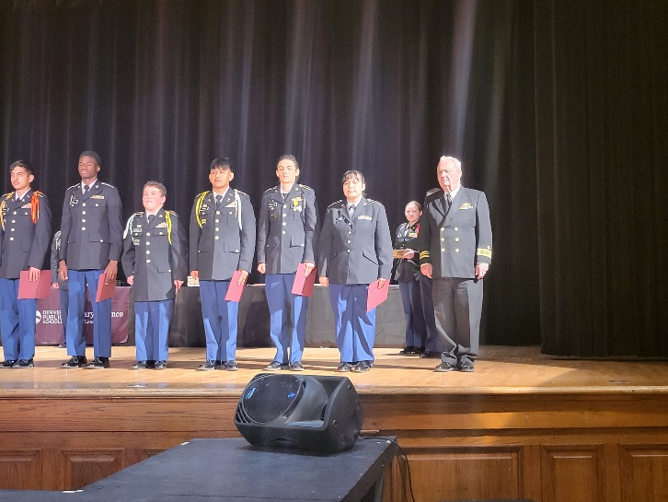

LCDR Coy Ritchie, Commander of the Denver Chapter, recently presented MOWW JROTC Award of Merit medals, ribbons, and certificates to 22 Army JROTC Cadets from the 11 JROTC Units in 11 Denver High Schools. LCDR Ritchie is on the extreme right. Unfortunately, the photographer was not able to fit all 22 cadets into the photo.

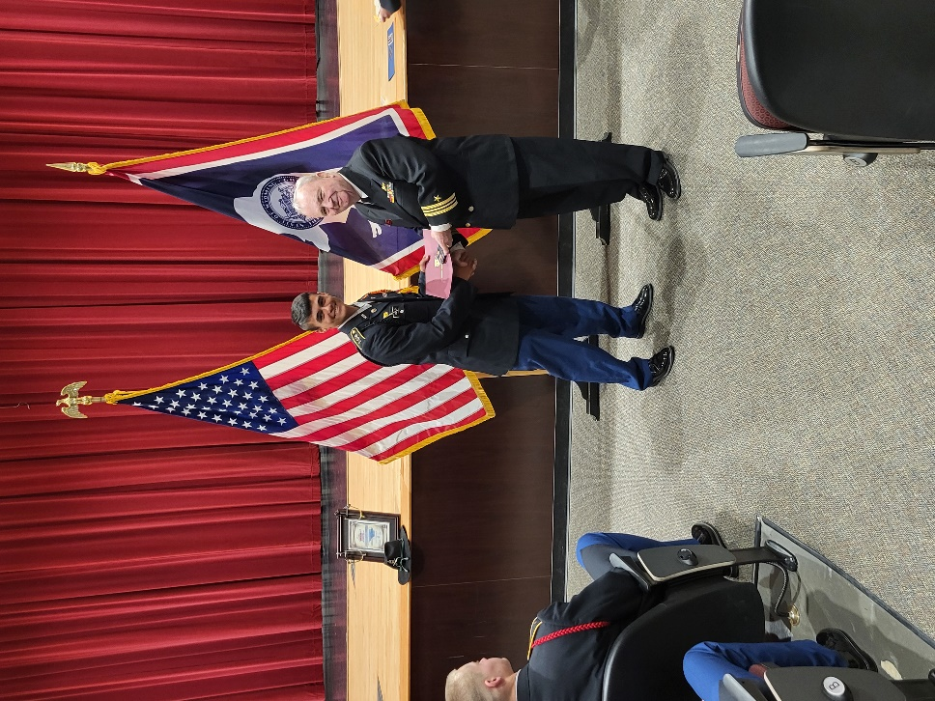

Cadet Kain Urdiales from the Army JROTC Unit at Cheyenne Central High School, Cheyenne, WY receives the MOWW JROTC Award of Merit Medal and Certificate from LCDR Coy Ritchie on 5/8/2024.



**POINTS OF CONTACT**



**MOWW Denver Chapter (093), CO**

c/o Coy D. Ritchie

4198 S. Kirk Court

Aurora, CO 80013-6022

[www.mowwscv.com/publications](http://www.mowwscv.com/publications)

**Commander and Treasurer**

LCDR Coy Ritchie, USN (Ret)

4198 South Kirk Court

Aurora, CO 80013-6022

303-690-5118 (Res), 303-981-5519 (Cell)

[coyritchie@aol.com](mailto:coyritchie@aol.com)

**Adjutant**

HPM Frances Long

6278 S. Kearney Street

Centennial, CO 80111-4237

303-694-1079 (Res)

[grannyfrancene@netzero.net](mailto:grannyfrancene@netzero.net)

**Commander, Rocky Mountains Department**

COL Steven A. Shambach, USA (Ret)

[shambachsm@msn.com](mailto:shambachsm@msn.com)

**Commander, Region XIII**

Currently vacant

**DENVER CHAPTER STAFF**

Denver Chapter Executive Board-Elected Officers

Commander: LCDR Coy Ritchie, USN (Ret) 303-981-5519

1st Vice Cdr: CPT Robert Mallin, USA (Fmr) 303-794-4790

2nd Vice Cdr: HPM Stephanie Ritchie 720-910-3647

Adjutant: HPM Frances Long 303-694-1079

Chaplain: HPM Frances Long 303-694-1079

Treasurer: LCDR Coy Ritchie, USN (Ret) 303-981-5519

Denver Chapter Staff: Committee Chairs

Membership: LCDR Coy Ritchie, USN (Ret) 303-981-5519

Newsletter Editor “ “

Public Relations: “ “

Finance & Budget: “ “

Rocky Mountain YLC: “ “

ROTC & JROTC: HPM Stephanie Ritchie 720-910-3647

Scouting: “ “

Programs: CPT Robert Mallin, USA (Fmr) 303-794-4790

Law & Order: Col Ron Rakowsky, USAF (Ret) 303-770-7121

Hospitality: HPM J. Pat Ritchie 303-690-5118

Marshall HPM Stephanie Ritchie 720-910-3647