COMMANDER’S LOG

Last month, I attended this year’s MOWW National Convention in Annapolis, MD. I have repeated my report on it below because many significant things happened. One of the major events was the adoption of a new 2023-2028 Strategic Plan. The six strategic goals in the plan are listed at the end of this newsletter.

Strategic Goal One: Consistently develop and deliver attractive, and high-impact community outreach programs and activities.

The objectives under this goal are:
>Adopt MOWW programs and activities to attract veterans who will donate their time, talents, and efforts towards improving the well-being of our Youth, Community, and Nation.
>Stimulate strong and sustainable growth at all organizational levels in both the quality and quantity of supportable outreach programs and activities.
>Increase engagement with key program stakeholders and subject matter experts.
>Assist local chapters to integrate community leaders who are not eligible for MOWW membership into chapter community outreach programs and activities such as the MOWW Patriot Program.

As support for this and other goals, the Order hired Jenna Tomas as MOWW’s New Outreach Program Manager. Jenna comes with a wealth of non-profit and program management experience. She will be working to promote, professionalize and advance our outreach programs. She can be reached at jtomas@moww.org. (703) 683-4911 Ext. 3.

In the coming months, we will see details on proposals of how to implement these objectives on a local basis.

THIS MONTH’S EVENTS

Fallen Warriors Interment
On Thursday September 28th, a ceremony will be held at Santa Fe National Cemetery prior to the interment of cremains of fallen warriors whose remains have not been claimed by family or friends. This ceremony is held quarterly and begins at 11:00 am. You may attend to honor those that have gone before and been forgotten.

THIS MONTH’S SPEAKER

This month’s speaker will be Los Alamos Fire Department Chief Troy Hughes. Chief Hughes will provide an update on the department including the current staffing numbers, the Baseline Needs Assessment for LANL, and updates on the acquisition of new fire apparatus and fire stations. He will also give some perspectives on current and upcoming challenges the department will likely face.

MEETING DETAILS

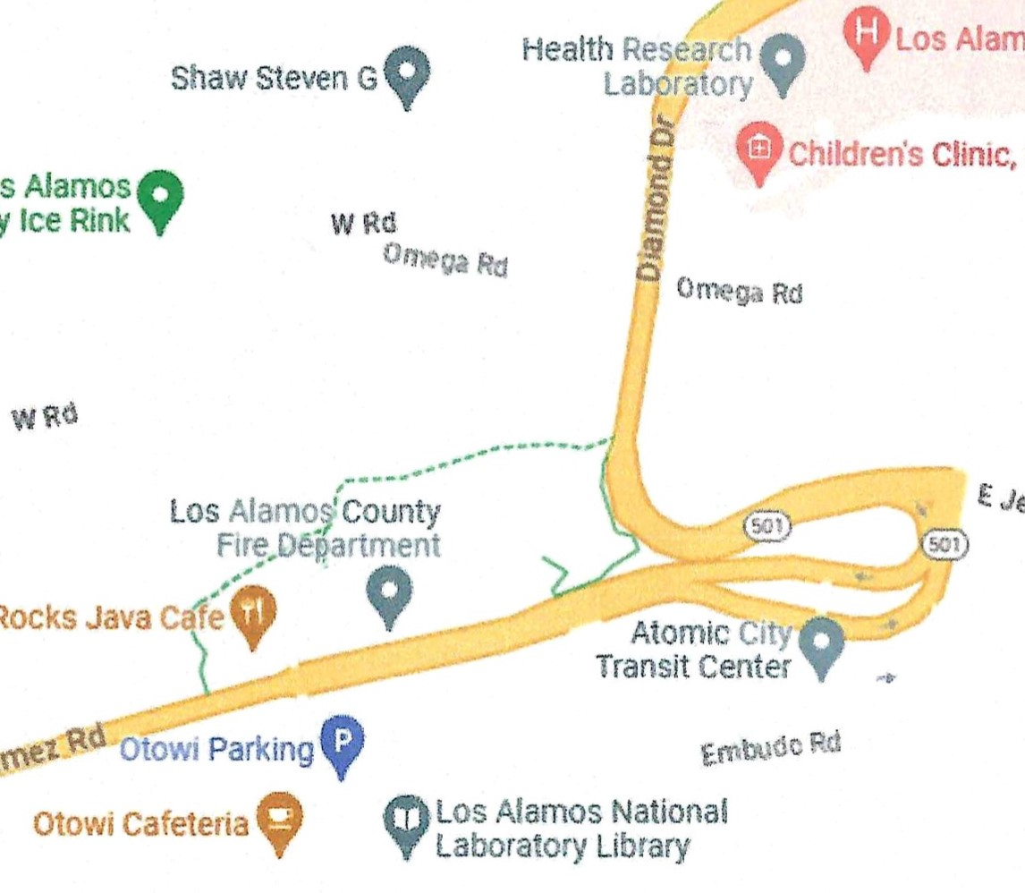

This month’s meeting will be on Tuesday September 19th. We will meet in the Los Alamos Research Park building room 203A. The building is labelled Hot Rocks Café in the map. The meeting will begin with a social period at 6:00 PM followed by a brief business meeting at 6;30 PM. There may be a presentation starting at about 7:15 PM.

The Military Order of the World Wars meetings are open to interested citizens.

The meeting will be a hybrid session including Zoom online. Zoom session will start at about 6:00 PM. Zoom details will be in the reminder email several days before the meeting.

LAST MONTH: SPEAKER

The speaker at our August 15th meeting which was held at the Los Alamos Research Park Building was Dr. Glen McDuff from LANL. One year ago, he told us about the various nuclear weapons the Army had over the years. This time. he talked about the nuclear weapons the Navy had starting with their involvement in the Manhattan Project.
He showed up wearing a T-shirt that said “Beat Army” in naval signal flags.

The Navy played an indispensable role in the development of the first atomic bombs. Four of the more notable participants were Captain William ‘Deke” Parsons, Commander Fred Ashworth, Commander Norris Bradbury, and Lt. Commander Francis Birch. Deke Parsons was an Associate Director of Project Y, the laboratory in Los Alamos. The first concept bomb design Thin Man was developed and tested at Dahlgren Naval Research Laboratory in !943 and included a test drop from an Avenger aircraft, not a B-29. Captain Deke Parsons was the weaponeer for the bomb drop on Hiroshima. A video clip of his report was played.

Commander Ashworth was the weaponeer for the Nagasaki mission. He oversaw all testing of the Fat Man design and was point man for the selection of the site for Project Alberta, the combat mission that ended up on Tinian Island. The mission over Nagasaki went bad, and they were running out of gas when they landed on Okinawa. Like the cartoons, they were ready to throw out parts of the plane to lighten the load. Later, now Admiral Ashworth said the pilot told the crew to fire the warning flares because they were going to make an emergency landing. There was a flare gun and box of flares in the top of the aircraft, red flares, yellow flares, green flares. As a Navy officer, Ashworth said he did not know what any of them meant. He fired all of them until he ran out. Imagine what the ground crew thought: they had wounded, they were on fire, they had stuck ordnance in the bomb bay? The plane landed, and everything was fine.

Lt. Commander Birch was a mechanical engineer and was chosen by Parsons to head the gun program. He worked at the Naval gun factory and was put in charge of the gun program because of his experience with guns and cannons in the past. He then showed three pictures. The first was a test cannon at Gun Site at Los Alamos used to test fire uranium projectiles. The second was the plutonium test gun for Thin Man. The third picture is the actual gun used in the Little Boy bomb dropped on Hiroshima while it was being tested at Gun Site. All the guns used in this project came from the U. S. Naval Gun Factory. This factory was only one of two factories that could machine the square threads used for the breeches of the guns.

There were 16 Litle Boy bombs, known as LB, sent to Tinian. Three were weaponized: L-7, L-8, and L-11. The rest were test units. The picture shows Lt. Comdr. Birch marking L-11, the combat bomb. While all the guns at that time had rifled barrels, Little Boy was a smooth bore design. The had to get a retired gun designer who had learned from a Civil War gun designer to design the gun.

Commander Bradbury was at the lab and was put in charge of the Trinity Test, the first test of an atomic bomb. After the war, approximately half of the Los Alamos staff left. Oppenheimer resigned as director in Fall, 1945. Groves and Oppenheimer wanted Bradbury to take the helm. Bradbury said no. They played to his good will. They told him he was a good American and was the best person for the job. Bradbury reluctantly agreed to serve for six months. Dr. Norris Bradbury was the director for the next 25 years and built the laboratory you see today.

After the war, the lab and town infrastructure crumbled. It was a daily struggle just to keep the lights on. The Army had left, and the University of California was not happy. The size of the lab was decreased so that it could accomplish its mission on the mesa with a civilian staff. Things looked bleak, and then Operation Crossroads. Norris Bradbury wrote “What held the place together was the Navy’s program to determine the effects of nuclear bombs against naval vessels.”

The Navy essentially hired the lab for the next six to nine months. Operation Crossroads was an interesting event. Immediately after the war, the Navy was worried about nuclear weapons because an aircraft carrier cannot outrun a plane. Admiral W.H.P. Blandy was in charge of the operation. The first test, Crossroads Able, was an air drop. It was a Fat Man bomb named Gilda after actress Rita Hayworth in the movie Gilda. That was because the movie was played at the base theater hundreds of times, so everyone had seen it. Not only did the operation have a theater, it had a newspaper and a radio station that played music 24 hours a day. There were 40,000 to 60,000 personnel involved in the operation. Crossroads Able was dropped on June 30, 1946 and produced a 21 kt yield.

Crossroads Baker was an underwater shot and was named Helen of Bikini, possibly after Helen of Troy. A complete deliverable bomb with tail fins and radars was placed in a water-proof container and lowered below a ship LSM-60. It was detonated on July 24, 1946 with a yield of 21 kt. The Navy was happy because the damage to ships was substantial, but not fatal.

A new threat emerged. In fall 1946, the Navy ordered more Little Boy’s even though they had no planes that could carry one. Norris Bradbury pointed that out, but the Navy insisted. To prove Bradbury wrong, in 1948 the Navy loaded a P2V aircraft by crane onto the USS Franklin Roosevelt, an aircraft carrier. With four JATO assists, the P2V lifted off with a 10,000-pound load, jettisoned the load, and landed inland as it could not land on a carrier. McDuff showed a picture of a Mk 1Second Generation LB created specifically for the Navy.

Another threat the Navy was concerned with was the Nazi submarine pens built it WW II all over Eastern and Western Europe. They had 33-foot-thick ceilings and were totally immune to conventional attack. Several of those were now controlled by the communists and immune to U.S. attack. The lab responded with an all new gun program which designed and produced the Mk 8 penetrator giving the U.S. its first atomic penetrator. This was a designed weapon as compared to the Hiroshima weapon which was a science project that in 144 days went from measuring the critical mass of uranium to delivering a working bomb. It took almost 12 months to design and build the Mk 8.

After LB came LC and then Elsie. Elmer was an attempt at a implosion-type penetrator, but it failed. The two were named after Borden products: Elsie the Cow on Borden milk, and Elmer after the white glue.

The Navy was interested in flying bombs as was the Army Air Force (AAF). Both began development on a flying bomb based on the Nazi V-1 flying bomb. Republic-Ford produced the JB-2 for the AAF and the LTV-N-2 ”Loon” for the Navy. He showed a picture off a Loon being launched from the deck of the submarine USS Cusk.

This became the first leg of the future triad. By having a long range (for the time) submarine-launched missile capability in 1950 was a massive advantage and was well publicized. So much so Hollywood got into the act. One movie was “The Flying Missile” starring Glenn Ford telling how the Loon was bootstrapped into the Regulus SSM-N-8. It was produced by Chance Vought Aircraft Co. It was originally planned to carry the Mk 8 penetrator but was ultimately armed with the Mk 5 implosion weapon. It was the first U.S. nuclear armed cruise missile, and it was controlled by the Navy. It was in service from 1954 to 1963. A picture was shown of a Regulus being launched from the submarine USS Halibut.

In 1957, the Soviets launched Sputnik with their R-7 rocket. It was an ICBM that could reach the U.S. However, it had poor accuracy. It had a circular error of ten to twenty miles which means that there was only a fifty percent probability it would land within twenty miles of the target. Therefore, Los Alamos was very safe from that rocket. The other problem was that the Soviets only had two rockets.

A year and a half later to give Khrushchev heartburn, the U.S. started missile mail. On June 8, 1959, a Regulus missile was launched from the USS Barbero from about 100 miles from the coast to the Naval Station at Mayport, Fl. Instead of a warhead, it carried two canisters containing 3000 letters. He showed a picture of the Postmaster General opening a door on the missile and removing the canisters with the mail. After this successful landing, the letters were hand delivered to President Eisenhower, V.P. Nixon, cabinet members, all the members of Congress, Supreme Court justices, and mailed to U.S. state governors, and the officers and crew of the Barbero. A picture of one of the envelopes was shown.

The press went wild. Why is the Navy wasting time and effort on this stunt using a nuclear missile to deliver mail. However, it was not just a mail delivery. In the height of the Cold War demonstrating that the U.S. could launch a missile that could fly 500 miles and deliver the mail (or a warhead) with pin point accuracy sent a message to any would be adversaries. The Soviets saw it differently. The had a missile that could hit Los Angeles which is fifty miles across, but we had a nuclear missile that we could land on a runway and a postman could get mail out of it. It sent a really different message to the Soviets. There is a Regulus movie available from Amazon or can be watched on Amazon Prime.

After WW II, the Army started the development of Artillery Fired Atomic Projectiles (AFAPs) based on acquired Nazi Gustave guns. This produced the 280 mm Atomic Annie cannons. He showed a video of the test firing of Atomic Annie with a nuclear projectile. It has a yield of 15 kt using a Thin Man type warhead. So the Navy had to have one. The Mk 23 “Katie” was developed for the 16”/50mm naval guns. It was in stockpile from 1956 to late 1959 and was never test fired. However, the last battleship was retired 8 March 1958, but some were later temporarily reactivated later. Therefore, for about nine months these were in the stockpile with no way to deliver them. This projectile was about 400 pounds lighter than the conventional explosive project for those guns.

The Navy did get depth bombs called Bettys. Weapon cases were considered secret in the 1950’s. AMF the builder of these promoted the U.S. nuclear might including an ad showing a woman’s hand crushing a submarine. Betty was one of the few weapons deployed on blimps. The blimps usually followed an aircraft carrier group because they traveled about the same speed as the group. One Betty can clear a path about ten miles in diameter of anything underwater. If a carrier group was under attack, two people in a blimp with one Betty can completely eliminate that threat.

After Betty came the W34 Lulu depth bomb. As with any development, these were smaller, lighter, more compact, and had a bigger yield.

The Navy entered the modern thermonuclear age with the Mk 27. Navy weapons were Mk while Army and Air Force weapons were W or B. This was a Livermore weapon, but it used all Los Alamos internal components. Other thermonuclear bombs of this time were too big to launch from carriers. This weapon was designed to be delivered from a North American Aircraft Company A-5 Vigilante Nuclear Attack Bomber which was designed for this weapon. The A-5 had a unique “linear bomb bay” in the center of the fuselage between the engines. The bomb would be delivered with the A-5 nose up and sliding out the end of the fuselage. This did give the Navy its first aircraft deliverable thermonuclear weapon.

We cant forget the JHU/APL, the John Hopkins University Applied Physics Lab Talos missile. It was in service from 1959 to 1979, 20 years, with the Mk 30 warhead. It was on guided missile cruisers. A cruiser carried 102 missiles in magazines like a rifle. They could be fired two at a time from front and rear of the cruiser about once every three minutes. The Talos was a beam rider which could be used against aircraft or surface to surface.

The Navy had another first. It had a QH-50 Drone Anti Submarine Helicopter (DASH) that could drop two Mk 44 or one Mk 46 torpedoes on an unsuspecting enemy. America’s first UAV was in service from Feb. 1961 to May 2006, and could carry a Mk 57 nuclear weapon. The Mk 57 was our first full fusing weapon. It could be used for air drop, retarded air drop, lay down, and had a depth bomb capability. This was the first drone approved to carry nuclear weapons, and it was back in the 1960’s.

A favorite weapon is the smallest nuke, the B54 Special Atomic Demolition Munition. It can be in a flotation bag to keep afloat while the Navy jumper gets out of his parachute and dons his scuba gear. It only weighs 51 pounds. The mission would be a underwater demolition specialist would parachute from an aircraft or exit a ship or submarine and swim with a propulsion device to the target, emplace the bomb, and swim back to be picked up by submarine or ship. The bomb had either a 24 hour or a 48 hour timer.

The Polaris A1 with a Mk 58 was a Livermore developed weapon was the first submarine launched missile. There about four versions of the Polaris. The Navy also had the B61, an Air Force weapon. The Navy’s nuclear division was active during Operation Desert Storm through 1992, but was gone in 1993 when the Navy denuclearized its surface fleet in 1993.

Today, we have the W76 on the Trident 1 missiles in the Ohio class submarines. It was deployed starting in the Navy in 1978 and is a big part of the triad. A Trident B5 missile can carry up to 8 warheads on its bus. Both the Air Force and the Navy have the W80 which was deployed in 1983. It is on the Tomahawk cruise missile which can be launched from submarines or surface ships. The Tomahawk is now gone so there are now no nuclear cruise missiles. The Trident II D5 missiles carry the W88 warhead which was deployed starting in 1988. The missile is celestial navigated using stars so that it is not dependent on GPS which can be spoofed. They also have inertial guidance.

McDuff showed a chart of all the nukes at sea. There were many gravity bombs and missiles two AFAPs, two depth bombs, one ADM, and three torpedoes. Torpedoes are an interesting item. The W34 Astor was referred as a “two fer”. It had a kill radius of five to ten miles while the typical battle is at about 2000 yards. So it would kill the enemy and the launching submarine.

He ended his presentation with a collage of the Navy’s nukes. Currently, the W76 and W88 on Trident missiles are the only Navy nukes today. Both are Los Alamos weapons. The videos referred to above as well as others that he showed are available on YouTube.

AWARDS

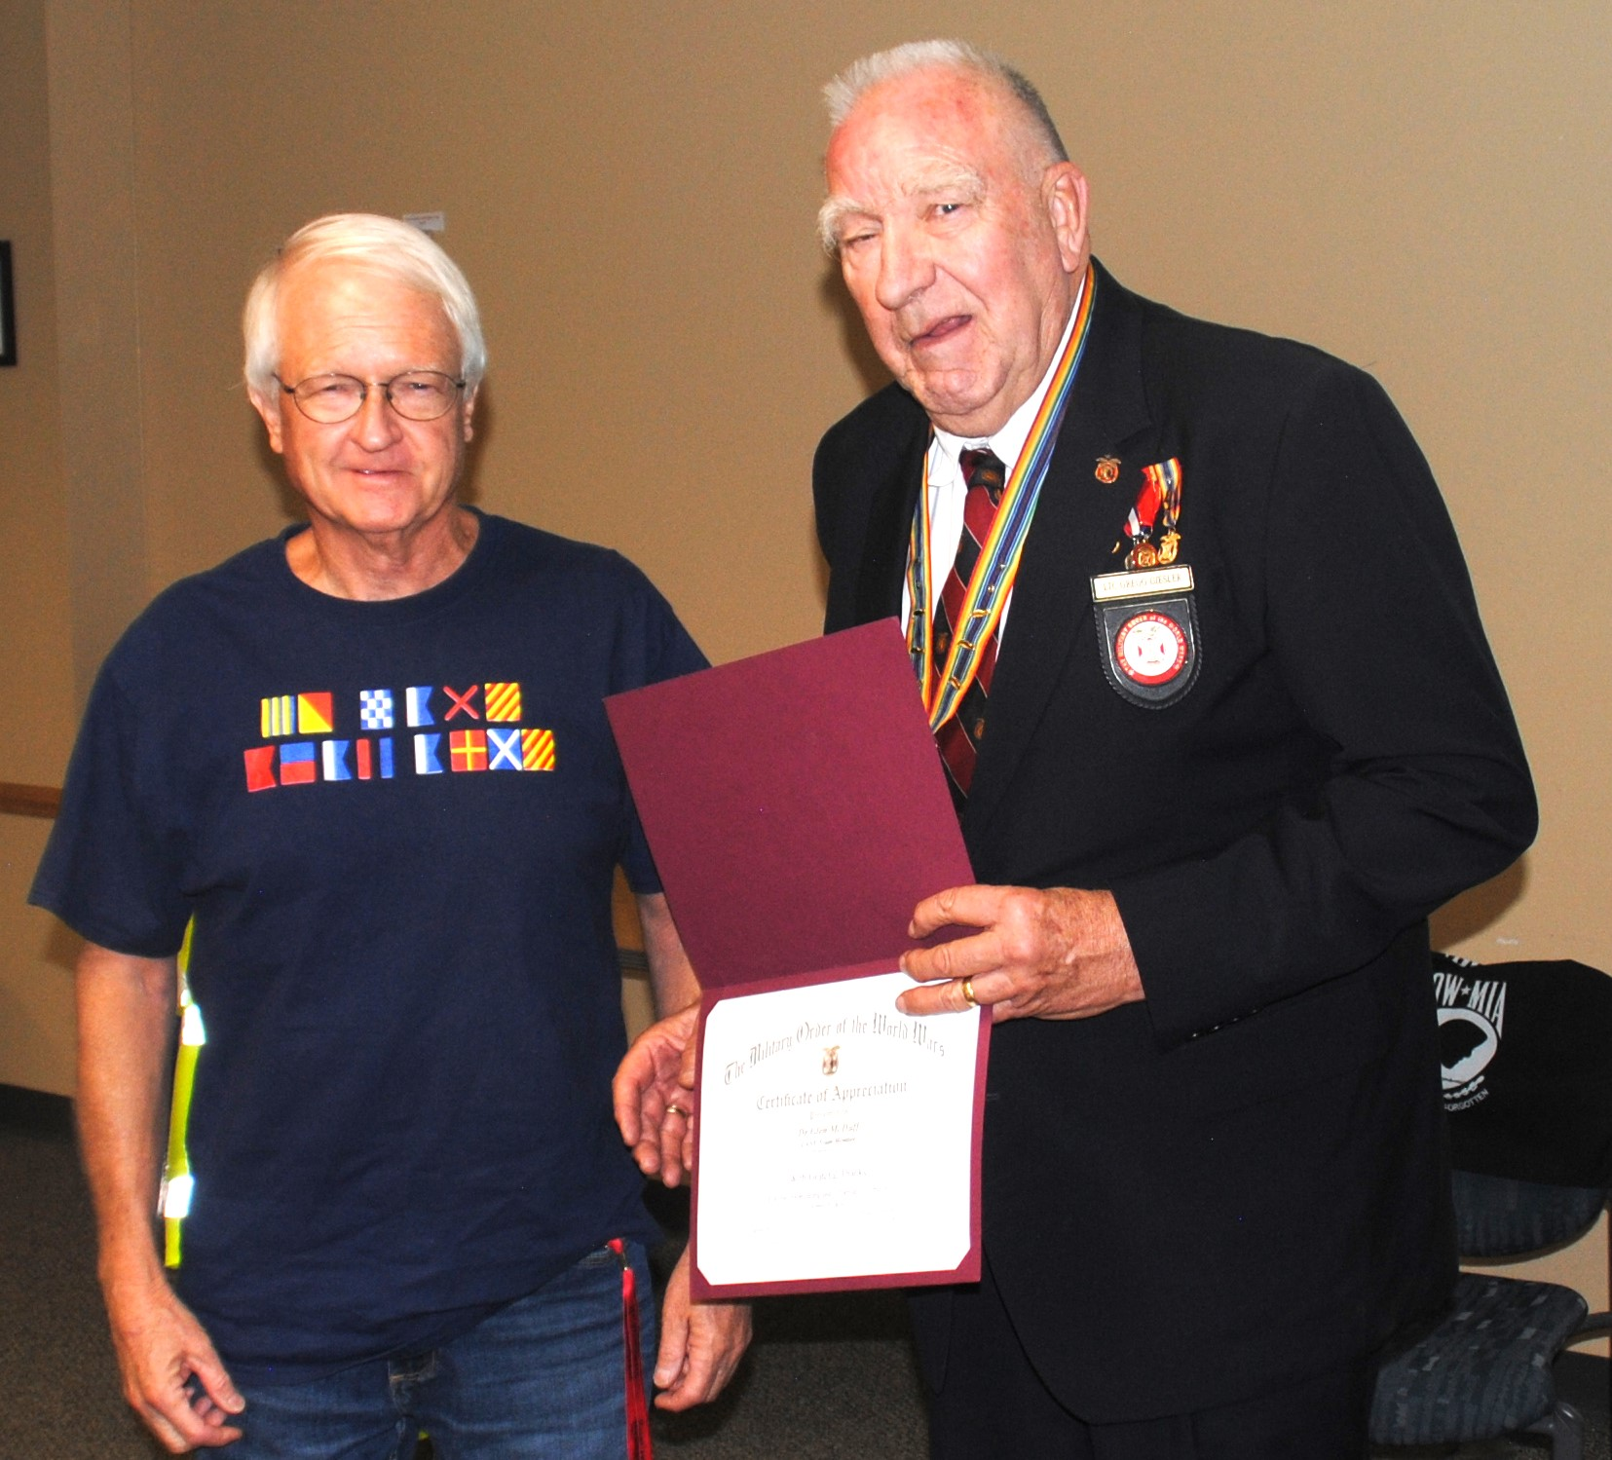

MG Miles Chapter Commander LTC Gregg Giesler USA (Ret) presents Certificate of Appreciation to Dr. Glenn McDuff for his presentation on Navy nuclear weapons. Dr McDuff worked for many years in the Weapons Programs office at Los Alamos National Laboratory and is very knowledgeable on nuclear weapons past and present in the national stockpile. He teaches classes on them in the Interservice Nuclear Weapons School.

LAHS NJROTC news

Welcome back to LAHS NJROTC newsletter August edition! We had a very busy first month of school! The first few weeks of class we started to teach our first years about all the good things in NJROTC. We had lessons on drill, Navy knowledge, uniform, and many more in order to prepare them for New Cadet Orientation. Our first-year cadets got a little taste of our team like unarmed drill, armed drill, color guard, and PT team while also showing off their new skills and knowledge. At the end of NCO the new cadets were awarded their JROTC-Bar, the very first piece of bling on their uniform. We are very proud and ecstatic about what the new cadets have accomplished and we can't wait to see what they bring to the unit! Congratulations to all of our first-year cadets!

Not only have we been supporting our new cadet but our very own Topper football team! Topper Company has been going out to the home football games to show off your color guard and stormer detail. Whenever the football team scores a touchdown Topper company runs out to the track and does however many points are on the scoreboard in pushups. We love obtaining our gains and showing support to our amazing football team! Next home game please come out to support the football team and our very courageous cadets!

Lastly, September is even crazier! Our first ever 5k Til’ Valhalla that is raising money for veteran suicide is happening on Sept 16, please come to Sullivan field at 8:00 AM to support our runners and the amazing cause! Homecoming is also coming up very soon Sept 18-23. We have a full schedule of events. We will have a color guard in the parade and cadets walking to show Topper pride! Come to both the parade and the homecoming game to see our football team Unplug the Chargers and Topper company do pushups for their hard work! As if Homecoming week can't get any busier, Sept 23 is our first dill meet at Albuquerque High School. Our competition teams consist of unarmed regulation drill, armed regulation drill, female/male color guard, and female/male PT teams. The teams have been working very hard since the beginning of school to prepare for Early Bird. Please Wish us luck! That's all for now thank you for reading, see you next time!

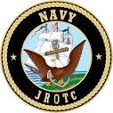
C/ENS Alana Hinojosa

FOR THE GOOD OF THE CHAPTER

The 2023 MOWW National Convention was held August 1-5 in Annapolis, MD. The convention began with a presentation on the new 2023-2028 Strategic Plan. The previous plan had an emphasis on recruiting. The new plan’s emphasis is on outreach and partnership with organizations that align with our mission both at the national level and the local level. Recruiting is still part of the plan, but at a lower priority.

That presentation was followed by a presentation on a National Youth Civics Summit scheduled for Summer 2024. It will bring about 15-16 outstanding youth to Washington, DC as a “Capstone” event. It will include an opportunity to observe the government in action including visits to executive departments and a possible meeting with a U.S. Senator or Representative. Visits to national monuments will be included. It will also promote MOWW in DC and nationwide.

The Digital Marketing & Social Media Ad Hoc Committee reported on efforts to promote MOWW in social media. It has presence in Facebook and Linkedin. The committee is planning to research the desired audience and build a presence on the right social media networks. Rallypoint appears to be a network commonly used by the military.

The committee is also looking at maintaining a branding voice for the Order. It will be developing consistent branding guidelines. It will create a social calendar and schedule with promotional, educational, and other items. It will also develop a social media plan. They will audit performance and evaluate trends. Social media is a customer service and security and privacy are important.

The Membership and Naming Ad Hoc Committees had short presentations. The Membership Committee will survey companions, nonmembers, and other organizations about whether to expand membership to include some or all enlisted veterans and whether it would have any effect on the membership of the Order. The Naming Committee will look at the possibility of changing the name of the Order so that it doesn’t sound like only veterans from the world wars. It will also be doing surveys and looking at the demand for, necessity, and the feasibility of a name change. You will be getting surveys in upcoming months and the committees will present a report to the EXCOM by 15 March 2024 so that any proposed changes to the constitution or bylaws can be submitted to the Constitution Committee.

In the MOWW Awards Luncheon, the chapter received a Medium Chapter National Security Program Third Place Award.

The Patriotic Education Committee session reported that all the forms for patriotic education events are now collected in the Forms 10 and 11 Series. Use of these forms provides the event with insurance coverage under the Order’s policy for anything that involves youth. An issue of high importance is the prevention of any kind of harassment. The insurance covers not only the event, but also travel on the day before and the day after the event. They also have a YLC/YLS Start Kit for those wanting to start a program.

The ROTC Committee reported among other things that cash awards and mailing costs can be included in the award application.

The Information and Publicity Committee request all companions look at and use the new logos and branding information on the MOWW website.

A presentation by the Historian General used the theme “Setting Course to the Future”. He reported that the Order has about 43 companions who are Medal of Honor Winners. Included in this list ate General Douglas McArthur and Audey Murphy, the most decorated soldier in WW II. They will be highlighted on the MOWW website, and a coffee table box describing them is being planned. There are three Medal of Honor museums in the U.S. with another planned for the DC Mall, and it planned to have a display in each highlighting their connection to MOWW.

Five U.S. Presidents have been honorary CINCs of the Order. Additionally, Harry S. Truman was also a companion of the Order in 1923. MOWW displays are planned for their presidential libraries.

A companion online autobiographical project is planned. Also, honoring the three “Founding Fathers” of the Order General Pershing, MG George Herbert Harries who got the Order going, and Captain Francis Bartholomew Grevemberg who wrote Preamble is planned. All three are buried in Arlington National Cemetery.

The MOWW Archives are stored in the Hoover Institute which is located about 90 miles north of Stanford University. Due to a 1996 agreement, the Institute is now the owner of the archives. They are no longer accepting deposits. Therefore, a new location for the archives is needed. The archives include over 371 boxes of materials. The contents of these boxes need to be cataloged in a searchable database.

As we set our course to the future, let us do it with hope, faith, courage, and intellect. The best way to predict the future is to create it.

At the Memorial Service, the chapter had three companions who died in the last year recognized: LT Carlton H. Darnell USN (Ret), 2LT James H, Duncan, Sr., USA (Fmr), and HPM Vernon V. Haywood, Jr.

At the business meeting, the CINC, VCINCs, and Chief of Staff presented their reports. The Finance Committee presented its report which included increases in the dues which were approved effective 1 January 2024. Other committees present their reports. The Strategic Plan described above and attached below was approved. Five constitutional amendments and two bylaw amendments were passed. All were minor changes and were reported in the Officer Review.

All the proposed candidates were elected. The IRS Compliance Ad Hoc Committee reported that the Order just meets the 75% veterans requirement for the IRS 501©(19) status. However, a number of chapters, including this one, are below the 75% level. Therefore, the Order will hold the applications for nonveteran HPM and HR members for those chapters until they are above that level.

The 2024 MOWW Convention will be held in the Crown Plaza Hotel, King of Prussia, PA in the first week of August. This hotel is just outside Philadelphia and near Valley Forge. The 2025 MOWW Convention will be hosted by Region XIII and held in the Desert Diamond Hotel in Tucson, AZ August 4-9. This is within driving distance. In 2026, the MOWW Convention will be held in San Antonio, TX.

At the closing banquet, Carol Grevemberg, the grandson to the creator of the Preamble, gave its history before reading it to start the banquet. The National Commanders Medal was presented to BG Victor Perez, the outgoing SVCINC and incoming CINC. The Distinguished Service Award was presented to VADM Sean Buck, the outgoing Superintendent of the U.S. Naval Academy. He was the guest speaker. The banquet ended with the change of command ceremony for the CINC.

Further information including all the reports are in the 2023 Almanac for Operating Year 2022 which can be found on the MOWW website.

NATIONAL OFFICERS

- COMMANDER IN CHIEF
BG Victor S. Perez, USA (Ret)
perezv56@gmail.com

- VICE COMMANDER IN CHIEF
Lt Col Marlon Ruiz, USAF (Ret)
ruizmarlon08@gmail.com

- REGION XIII COMMANDER
Capt Michael J. Halpin, USMC
usmcf4gib@yahoo.com

Region XIII website www.MOWWSCV.com

NATIONAL STAFF

- CHIEF OF STAFF & COO
Col Michael Farrell, USMC (Ret) | chiefofstaff@moww.org

- DIRECTOR OF FINANCE
finance@moww.org

- MANAGER, MEMBERSHIP PROGRAMS (including dues payments)
HPM Justin Hiller | membership@moww.org

- MANAGER, MOWW STORE
Mrs. Sunny Alley | merchandise@moww.org

Website www.moww.org

MG MILES CHAPTER OFFICERS

Commander
LTC Gregg Giesler USA (Ret)
Home: 505-662-5574
g.giesler@computer.org

Senior Vice Commander
MAJ Robert Hull USAF (Ret)
Home: 505-662-7950
rhull@lata.com

Adjutant
HPM Robert Malone
Home: 505-672-0248
Robert_malone2@aol.com

Treasurer
MAJ Robert Hull USAF (Ret)
Home: 505-662-7950
rhull@lata.com

COMING EVENTS

September National Emergency Preparedness Month
11 Staff Meeting –
19 Chapter Dinner – LAFD Chief Troy Hughes

October
9 Staff Meeting
17 Chapter Dinner –

November
13 Staff Meeting
18 Chapter Lunch at Pecos Trail Café

MOWW VISION

A strong America, dedicated to preserving and advancing American Ideals and Founding Principles.

MOWW MISSION

The Military Order of the World Wars serves our nation and local communities by providing and supporting activities that promote and encourage responsible citizenship, patriotism, youth leadership, military and public service, veteran support, and strong national security.

MOWW STRATEGIC GOALS

Strategic Goal One: Consistently develop and deliver attractive, and high-impact community outreach programs and activities.

Strategic Goal Two: Expand our impact through alliances and strategic partnerships with organizations that align with our missions.

Strategic Goal Three: Increase visibility of the Order at the national and local community levels through focused communication, marketing strategies, and local community engagement.

Strategic Goal Four: Annually grow engaged and sustainable MOWW membership.

Strategic Goal Five: Increase revenues ensuring adequate financial resources to fulfill the Order’s mission.

Strategic Goal Six: Increase the number of chapters and strengthen existing chapters.

