**COMMANDER’S REMARKS (6 July 2024)**

We will have our next General Membership Meeting on Saturday, 19 October 2024, starting at 11:30 A.M. The meeting will be held at Las Brisas Restaurant, 6787 S. Clinton Street, Greenwood Village, CO. Our featured speaker will the LtCol Pete Nielsen, USAF (Retired) who is the Senior Aerospace Science Instructor at Aurora Central High School.

To get there (Las Brisas Restaurant), if you are coming from east of I25, drive west on Arapahoe Road to South Clinton Street (about a block before you get to I25) and take a left turn. Do not turn on Clinton Court as the next street is South Clinton Street. The restaurant is located on the east side of the Target Store parking lot. If you are coming from west of I25, drive east on Arapahoe Road until you pass under I25. The first street on the right is South Clinton Street. Turn right and you will see the restaurant on the east side of the Target Store parking lot. If you get lost, you can call me at 303-981-5519 (cell) and I will try to get you un-lost.

Coy D. Ritchie, D.M.

LCDR, USN (Ret)

Denver Chapter Commander

It is nobler to serve than to be served



**COMING EVENTS (June & Later)**

* **STAFF MEETING (12 September 2024)**
  + (Thursday), 11:00 A.M.
  + Location: Frances Long’s Home
* **MOWW NATIONAL CONVENTION**

**(August 5-11, 2024)**

* + Location: Valley Forge, PA
* **MEMBERSHIP LUNCHEON**

**(19 October 2024)**

* + (Saturday), time 11:30 A.M.
  + Location: Las Brisas Restaurant, 6787 S. Clinton Street, Greenwood Village, CO.
  + Menu: Order from the menu.
  + Program: Lt Col Pete Nielsen, USAF (Ret), speaking about the Air Force JROTC Program.



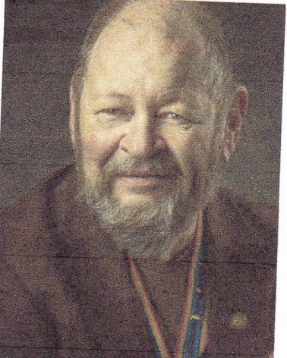

**Bob**

PLANNING AHEAD

CPT (DR) Robert E. Mallin, USA (Fmr)

Surgeon General, MOWW

How to face reality and help your loved ones: You can, in advance plan for a spot in a national cemetery. Check the rules. Get your “permit” well in advance. Have several copies of your DD-214, draw up a will, and have a living will to express your wishes—before circumstances dictate them. Another wise move is deciding who will make decisions for you when you are unable to do so yourself. A medical directive or a more general power of attorney to a trusted person can be made “just in case” to express your wishes and provide guidance on likely decisions.

I remember in practice some family members saying, “Do all you can.” This may have salved their conscience but it did not take into consideration the patient’s feelings. Many burn patients opted to being “comfortable” while nature took its course, thus avoiding many painful and fruitless procedures. An earlier trip to the Emergency Room revealed they offered Living Will forms. Once you lose the old- fashioned idea that tasking of such things brings them on, take advantage of advance planning. Make three copies of our will, etc. Keep one for your use. Give one copy to your doctor, and provide one to the “person who will make decisions.” In addition, a reduced copy of a living will can fit in your wallet. A good idea is also to do a review of your insurance policies.

Life insurance can be costly, especially, when your kids are grown and doing well. You may not still need such a financial burden. I find I can use the expensive premiums to enjoy myself. By the way, I ensure the kids have my will, which I review yearly. They do not need an insurance policy too! However, an Old Age Care Policy is a good option. The younger you are, the cheaper the premium. This policy can cover home care, hospice care, etc. I got mine at 54. It gives a certain comfort to me and will to my family when the time comes. As hard as it is to discuss your thoughts with the family, you should think about it.

Perhaps you might make a video for that “last visit.” If you are facing the inevitable, keep control of things. You deciding about your burial wishes, music, pallbearers, etc., keeps you in control and is a real gift to the family. Many people opt for giving their treasured items to those in their will now, not later, so they can see them being enjoyed. I took a Kubler-Ross seminar once. She asked the question, “What things would you do if you had two hours to live?” After fielding the answers, she said, “Why not do them now?” Why not, indeed? Never going to bed angry, telling people your feelings, etc., may be concepts I have picked up living in Santa Fe, but they are something you might consider. My father used to say, “Take advantage of time. The only thing you know for sure is the only thing for which you are never fully prepared.” Be well / Bob

*The Military Order of the World Wars THE OFFICER REVIEW September 2017 p22*

*CPT (Dr.) Robert E. Mallin, USA (Former) is a graduate of Adelphi University and New York Medical College. He is certified with the American Board of Plastic and Reconstructive Surgery and is a Fellow of the American College of Surgeons. In private practice from 1975-94, he was the Alaskan State Physician of the Year. While in the U.S. Army (1966-1968) he earned a Bronze Star, Purple Heart and Air Medal, and a Combat Medical Badge, among other decorations.*



**PREVIOUS MEMBERSHIP MEETING SPEAKER**

**(19 APR 2024)**

Landry Terry from The Veterans Treatment Court gave a very interesting presentation about the Second Chance Program which provides veterans who have been arrested a second chance without being incarcerated.





**THE PREAMBLE**

To cherish the memories and associations of the World Wars waged for humanity;

To inculcate and stimulate love of our country and flag;

To promote and further patriotic education in our nation;

Ever to maintain law and order, and defend the honor, integrity, and supremacy of our national government and the Constitution of the United States;

To foster fraternal relations among all branches of the armed forces;

To promote the cultivation of military, naval, and air science and the adoption of a consistent and suitable policy of national security for the United States of America;

To acquire and preserve records of individual services;

To encourage and assist in the holding of commemorations and the establishment of memorials of the World Wars; and

To transmit all these ideals to posterity; under God and for our country, we unite to establish**…**

**The Military Order of the World Wars**



**ELECTION AND INSTALLATION OF DENVER CHAPTER OFFICERS FOR OPEATING YEAR 2024**

During the General Membership Meeting on 15 June, the Nominating Committee presented the companions they had selected as nominees for election as Denver Chapter Officers for the 2024 Operating Year. There were no nominations from the floor. CPT Bob Mallin made a motion that the nominees be elected by acclamation. The motion was seconded by HPM Frances Long and they were elected unanimously. The new Officers are Treasurer – LCDR Coy Ritchie, Adjutant – HPM Frances Long, Second Vice Commander – HPM Stephanie Ritchie, First Vice Commander – CPT Bob Mallin, and Commander – LCDR Coy Ritchie.

After the election, the Chapter Officers were installed by COL Steven Shambach, Commander of the Rocky Mountain Department.

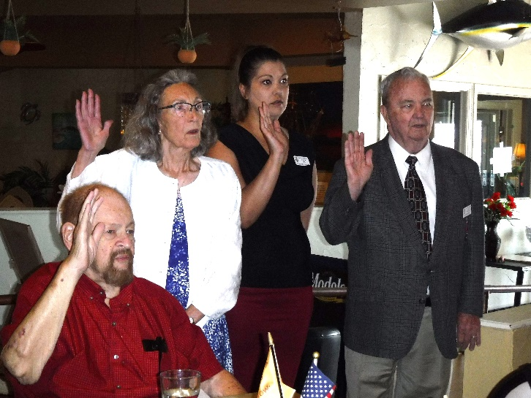

**Denver Chapter Officers are administered their oath of office by COL Steven Shambach. (L to R) CPT Bob Mallin, HPM Frances Long, HPM Stephanie Ritchie**

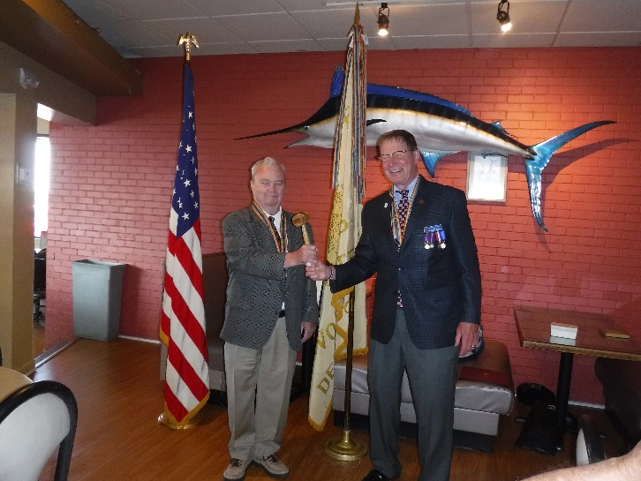

**LCDR Coy Ritchie (L) is installed as Denver Chapter Commander by COL Steven Shambach (R), Rocky Mountain Department Commander.**

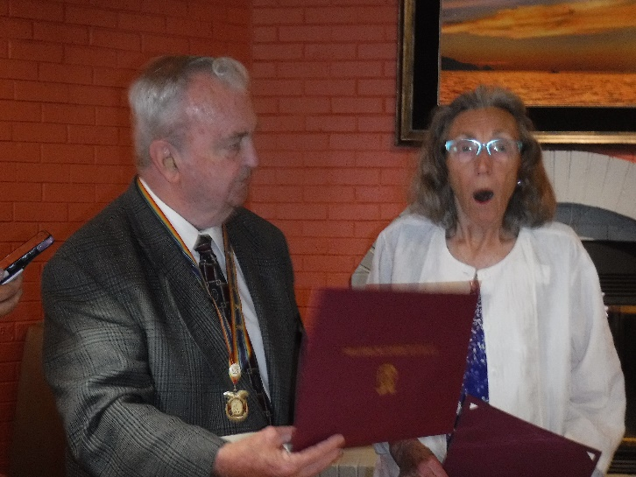

**HPM Francis Long is awarded a National Citation and a Silver Patrick Henry Medal for her eight outstanding years of service as the Adjutant for the Denver Chapter.**

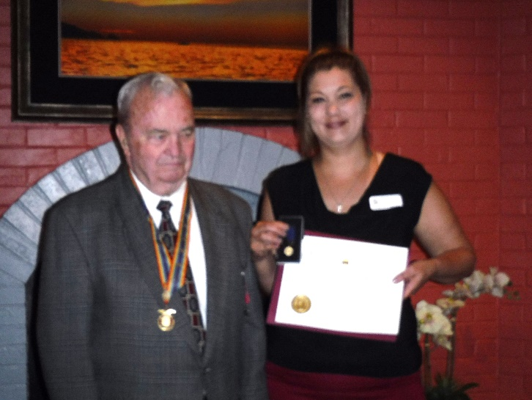

**HPM Stephanie Ritchie is awarded the Outreach Service Medal for her outstanding performance as Chair of the Denver Chapter ROTC Committee.**

**TODAY IN NAVAL HISTORY**

29 JUNE 1776

**BATTLE OF TURTLE GUT INLET**

The six-gun civilian brig *Nancy* headed north from St. Thomas and St. Croix. Her Master, Hugh Montgomery, had shipped a cargo that would bring a handsome profit in his homeport of Philadelphia. *Nancy* carried 386 barrels of gunpowder, sorely needed in anticipation of the declaration American independence, 50 fire-locks, 101 hogsheads of rum and 62 hogsheads of sugar. But as *Nancy* approached the mouth of the Delaware River on Friday evening June 28th, the British warships, *HMS ORPHEUS, 312, LIVERPOOL, 28, and KINKFISHER, 16* gave chase.

American lookouts at Cape May watched the chase unfold, Nancy being forced toward a small bay north of Cape May, Turtle Gut. Word was sent to CAPT John Barry in the Continental Navy brig *LEXINGTON, 14*, who was standing by to assist vessels attempting to bring run past the British into Philadelphia. He, along with CAPT Lambert Wickes in *REPRISAL*, 18, and CAPT John Bauldwin in *WASP*, 8, hurriedly met at nightfall to assess the situation. Meanwhile, near the inlet to Turtle Gut, Nancy ran aground in the pitch-black night, unseen by the British. LT Richard Wickes, *REPRISAL*’s 3rd LT and brother of skipper Lambert Wickes, insisted upon commanding a longboat for *Nancy*’s aid. But he could not find the subject brig in the darkness that night. Not until dawn did LT Wickes reach *Nancy*, about the same time the shallow-drafted sloop *HMS KINGFISHER* anchored within 300 yards. Just as Barry and more American longboats arrived, the British launched their own boat party!

LT Wickes quickly set his men to two tasks, one lightering *Nancy’s* cargo and the other to serve *Nancy’s* guns. *KINGFISHER* opened fire while American patriots fought off the British boarding party. *KINGFISHER’s* longboat was beaten back, and in response the sloop quickened her fire. *KINGFISHER* pummeled *Nancy* for half an hour, cutting her alow and aloft. Then five more boats were launched from *KINGFISHER*, this time intent on boarding at all costs.

By now Wickes’ men had off-loaded the muskets, much of the dry goods, and 265 barrels of gunpowder. The enemy bombardment took its toll; it was soon clear the merchant brig could not be saved. Barry now staged an ingenious booby-trap, wrapping the remaining barrels of gunpowder in a sail which he ignited as a sort of fuse. The last man off Nancy climbed the rigging to lower our flag, and at that very moment, LT Wickes was sliced through the arm and chest with an enemy shot. The approaching British interpreted the flag lowering as surrender, and just as they clamored aboard, the gunpowder exploded in a blast felt miles away. Seven Royal Navy tars died, and several of their longboats were destroyed.

CAPT James Bloom, Ret

Captain Lambert Wickes to Samuel Wickes, dtd. 2 July 1776. IN: Morgan, William James, (ed.), Department of the Navy, Naval History Division. Naval Documents of the American Revolution Vol 5 1776, Washington, DC: GPO, 1970m pp. 882-84.

Department of the Navy, Naval History Division. Dictionary of American Naval Fighting Ships, Vol 4 “L-M”. Washington, DC: GPO, 1969, p. 100.

Department of the Navy, Naval History Division. Dictionary of American Naval Fighting Ships, Vol 6 “R-S”. Washington, DC: GPO, 1976m p. 78.

Department of the Navy, Naval History Division. Dictionary of American Naval Fighting Ships, Vol 8 “W-Z”. Washington, DC: GPO, 1981, p. 293.

“Journal of the H.M. Sloop *Kingfisher*, Captain Alexander Graeme.” IN: Morgan, William James, (ed.), Department of the Navy, Naval History Division. Naval Documents of the American Revolution Vol 5 1776. Washington, DC: GPO, 1970, pp. 817-18.

“Journal of the H.M.S. Orpheus, Captain Charles Hudson.” IN: Morgan, William James, (ed.), Department of the Navy, Naval History Division. Naval Documents of the American Revolution Vol 5 1776. Washington, DC: GPO, 1970, p. 818.

ADDITIONAL NOTES: This engagement transpired only a week before our independence was declared and is taken by historians as the first government-sponsored naval battle of our Revolutionary War. Regardless, it has largely been forgotten. This may be due in part to the fact that Turtle Gut has since been backfilled by Cape May County authorities. A park now occupies the site bearing a marker commemorating the battle that took place this day. CAPT Lambert Wickes is remembered today with the lead ship in a class of WWI destroyers, *WICKES (DD-73)*, and with the Fletcher-class WWII destroyer DD-578.



**MEMBERSHIP APPLICATIONS**

Applications may be obtained by contacting the Chair of the Membership Committee at 303-981-5519 or [coyritchie@aol.com](mailto:coyritchie@aol.com).

It is nobler to serve than to be served



**THE CINC SOLICITATION**

The Commander in Chief is appealing to you to donate generously to the CINC Solicitation by donating in support of our Order’s patriotic and educational activities. He also asks that you encourage other Companions in your chapter to do so too. Our CINC Solicitation goal helps pay for activities such as:

* Supporting chapters via essential services (e.g., YLC insurance) and merchandise (i.e., products of all types)
* Existing awards, e.g., ROTC/JROTC Awards of merit, GSUSA Gold Award, and BSA Eagle Scout Certificates
* New awards, e.g., Outreach Service Medal and BSA Sea Scout, Quartermaster and Venture Scout Certificates
* Service Academy awards and military college awards
* Medals & certificates to ROTC/JROTC cadets & BSA & GSA scouts not supported by chapters
* Promotional material and program brochures for existing and start-up chapters
* The *Officer Review* magazine, which is MOWW’s only way to communicate with all Companions
* YLC Support via additional YLC issues of the O*fficer Review* that YLC Directors use for advertising & recruiting
* The MOWW website at [www.moww.org](http://www.moww.org), which the Order’s Companions use in support of every activity area
* MOWW Convention Support, including the Distinguished Service and National Commander Award programs

It is very easy to contribute, just open up the Order’s web page and at the very top next to the logo is the DONATE tab. You can also mail in your contribution when you receive the solicitation in the mail from MOWW HQ.

Your donation supports patriotic activities only MOWW provides. *Please donate today!*



**POINTS OF CONTACT**

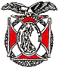

**MOWW Denver Chapter (093), CO**

c/o Coy D. Ritchie

4198 S. Kirk Court

Aurora, CO 80013-6022

[www.mowwscv.com/publications](http://www.mowwscv.com/publications)

**Commander and Treasurer**

LCDR Coy Ritchie, USN (Ret)

4198 South Kirk Court

Aurora, CO 80013-6022

303-690-5118 (Res), 303-981-5519 (Cell)

[coyritchie@aol.com](mailto:coyritchie@aol.com)

**Adjutant**

HPM Frances Long

6278 S. Kearney Street

Centennial, CO 80111-4237

303-694-1079 (Res)

[grannyfrancene@netzero.net](mailto:grannyfrancene@netzero.net)

**Commander, Rocky Mountains Department**

COL Steven A. Shambach, USA (Ret)

[shambachsm@msn.com](mailto:shambachsm@msn.com)

**Commander, Region XIII**

Currently vacant

**DENVER CHAPTER STAFF**

Denver Chapter Executive Board-Elected Officers

Commander: LCDR Coy Ritchie, USN (Ret) 303-981-5519

1st Vice Cdr: CPT Robert Mallin, USA (Fmr) 303-794-4790

2nd Vice Cdr: HPM Stephanie Ritchie 720-910-3647

Adjutant: HPM Frances Long 303-694-1079

Chaplain: HPM Frances Long 303-694-1079

Treasurer: LCDR Coy Ritchie, USN (Ret) 303-981-5519

Denver Chapter Staff: Committee Chairs

Membership: LCDR Coy Ritchie, USN (Ret) 303-981-5519

Newsletter Editor “ “

Public Relations: “ “

Finance & Budget: “ “

Rocky Mountain YLC: “ “

ROTC & JROTC: HPM Stephanie Ritchie 720-910-3647

Scouting: “ “

Programs: CPT Robert Mallin, USA (Fmr) 303-794-4790

Law & Order: Col Ron Rakowsky, USAF (Ret) 303-770-7121

Hospitality: HPM J. Pat Ritchie 303-690-5118

Marshall HPM Stephanie Ritchie 720-910-3647