**COMMANDER’S REMARKS (9 January 2025)**

We will have our next General Membership Meeting on Saturday, 15 February 2025, starting at 11:30 A.M. The meeting will be held at Las Brisas Restaurant, 6787 S. Clinton Street, Greenwood Village, CO.

To get there (Las Brisas Restaurant), if you are coming from east of I25, drive west on Arapahoe Road to South Clinton Street (about a block before you get to I25) and take a left turn. Do not turn on Clinton Court as the next street is South Clinton Street. The restaurant is located on the east side of the Target Store parking lot. If you are coming from west of I25, drive east on Arapahoe Road until you pass under I25. The first street on the right is South Clinton Street. Turn right and you will see the restaurant on the east side of the Target Store parking lot. If you get lost, you can call me at 303-981-5519 (cell) and I will try to get you un-lost.

I am looking forward to seeing all of you at our luncheon on Saturday, 15 February 2025.

Coy D. Ritchie, D.M.

LCDR, USN (Ret)

It is nobler to serve than to be served

______________________________________________________________________________________________________________________

**STAFF MEETING (12 December 2024)**

This meeting was conducted at Frances Long’s home and was called to order by Chapter Commander Coy Ritchie at 1104 hours. Also attending were HPM Stephanie Ritchie, HPM Pat Ritchie, and HPM Francis Long. The invocation was offered by HPM Frances Long followed by the Pledge of Allegiance.

Minutes: The minutes of the staff meeting on 12 December 2024 were approved on a motion by HPM Stephanie Ritchie and seconded by HPM Pat Ritchie.

Treasurer’s Report: Treasurer’s Report as of 31 December 2024 was submitted by LCDR Ritchie. There was no change since last month. The U.S. Bank checking account remained at $2,673.62. The ENT Credit Union account remained at $9,283.70. The Treasurer’s Report was approved on a motion by HPM Pat Ritchie and seconded by HPM Stephanie Ritchie.

Scouts: Nothing new to report.

ROTC/JROTC: Responses from the high schools and universities are beginning to come in.

Patriotic Education: LCDR Coy Ritchie and Col R.F. Smith gave a presentation to 35 JROTC instructors from the Denver Public Schools about the upcoming Rocky Mountain Youth Leadership Conference to be held in June 2025.

Public Safety and Law and Order: A speaker for February 2025 is been arranged.

Region XIII and Department of the Rocky Mountains:

A Region XIII conference will be held on 16-19 January 2025 in Tucson, Arizona. The Region XIII business meeting will be conducted on 17 January 2025. Coy and Pat Ritchie will attend.

Membership: Efforts to recruit new members are ongoing.

Program/Speaker: Capt Dennis Orr is arranging a speaker on Homeland Security for the membership meeting on 15 February 2025.

Hospitality: The next luncheon is on Saturday, February 15, 2025 at Las Brisas Restaurant starting at 1130 hours. We will order from the menu.

Old Business: Nothing to report.

New Business: A proposal to contribute $600.00 to the Rocky Mountain Youth Leadership Foundation to fund one student for the YLC passed on a motion by HPM Frances Long and seconded by HPM Pat Ritchie. The Chapter will consider a contribution to the UVC soon.

Next Staff Meeting: Thursday, 6 February 2025, starting at 1100 hours at the home of HPM Frances Long.

Benediction: Given by HPM Frances Long.

Adjournment LCDR Ritchie adjourned the meeting at 1130 hours.

Submitted by Adjutant HPM Frances Long



**COMING EVENTS (October & Later)**

* **STAFF MEETING (6 February 2025)**
  + (Thursday), 11:00 A.M.
  + Location: Frances Long’s Home
* **MOWW NATIONAL CONVENTION**

**(August, 2025)**

* + Location: Tucson, Arizona
* **MEMBERSHIP LUNCHEON**

**(15 February 2025)**

* + (Saturday), time 11:30 A.M.
  + Location: Las Brisas Restaurant, 6787 S. Clinton Street, Greenwood Village, CO.
  + Menu: Order from the menu.
  + Program: A speaker on Homeland Security is being arranged.



**PREVIOUS MEMBERSHIP MEETING SPEAKER**

**(21 DEC 2024)**

SMSgt Steven Seiler, USAF Aerospace Science Instructor in the JROTC Program at Aurora Central High School gave an outstanding presentation about the USAF JROTC Program and the program at Aurora Central High School.



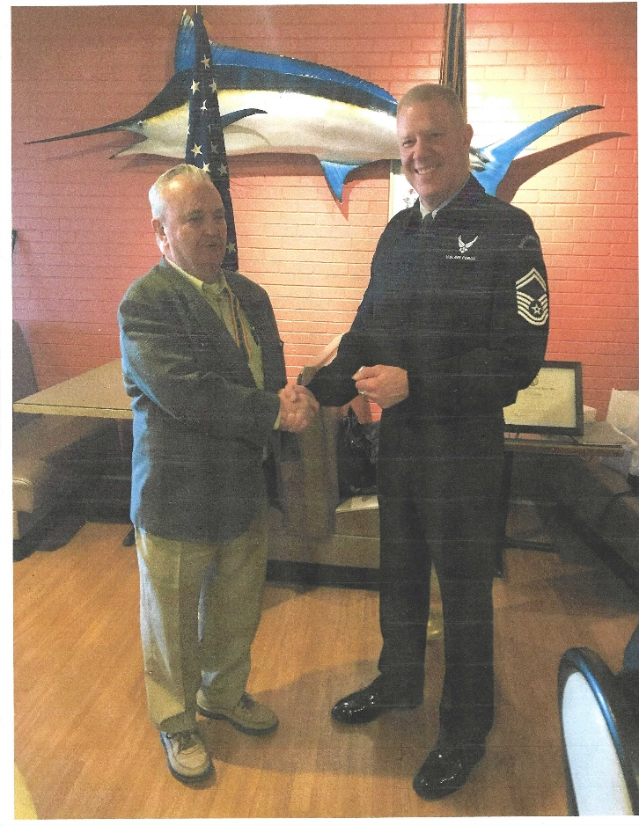

LCDR Coy Ritchie (L) presents SMSgt Steven Seiler (R) with the MOWW Coin of Excellence and congratulates him on his excellent presentation on the USAF JROTC Program at Aurora Central High School.

_____________________________________________________

_____________________________________________________



**THE PREAMBLE**

To cherish the memories and associations of the World Wars waged for humanity;

To inculcate and stimulate love of our country and flag;

To promote and further patriotic education in our nation;

Ever to maintain law and order, and defend the honor, integrity, and supremacy of our national government and the Constitution of the United States;

To foster fraternal relations among all branches of the armed forces;

To promote the cultivation of military, naval, and air science and the adoption of a consistent and suitable policy of national security for the United States of America;

To acquire and preserve records of individual services;

To encourage and assist in the holding of commemorations and the establishment of memorials of the World Wars; and

To transmit all these ideals to posterity; under God and for our country, we unite to establish**…**

**The Military Order of the World Wars**



**TODAY IN NAVAL HISTORY**

**8 JANUARY 1907**

**THE ORIGIN OF “U.S.S.”**

Prior to the 20th century there was no policy governing the titling of U.S. warships in official correspondence. Navy vessels were sometimes distinguished from merchant or research ships by writing out the words “United States Ship” in front of their name. Alternatively, the type of vessel might be referenced (“United States Frigate *CONSTELLATION*”}. Occasionally the ships rigging (“United States Brig *SOMERS*”) or mission (United States Flag-Ship *CONGRESS*”) formed the basis of her identification. Following the Civil War, a simple “U.S.S.” prefix fell into unofficial usage; however, none of these practices was universal or mandatory.

Then the last century dawned upon a worldwide upsurge in navalism. Our nation’s success in the 1898 Spanish-American war was followed by Theodore Roosevelt’s presidency, in which the battleship, in particular, became his “big stick” of foreign policy. Our Navy enjoyed a great expansion. In the year 1906 alone, no less than six new battleships were commissioned. In June of 1906, Congress made an extraordinary authorization in the case of *DELAWARE (BB-28)*, unprecedented in that it included no limit on her tonnage! By late 1906, planning was underway on the unrivaled endeavor of sending our Atlantic Battleship fleet (the so-called “Great White Fleet”) on a world cruise. Elsewhere that same year Britain commissioned *HMS DREADNOUGHT*, the most powerful battleship to date. Similar U.S. designs had already been approved and on December 17theand 18th, respectively, the keels were laid for *MICHIGAN (BB 27)* and *SOUTH CAROLINA (BB-26)*, our first *Dreadnought*-type, all-big-gun battlewagons. It is understandable that amid this naval ascendancy Roosevelt would require that U.S. warships be formally designated as official agents of our government. On this date President Roosevelt issued Executive Order 549:

*In order that there shall be uniformity in the manner of designating naval vessels, it is hereby directed that the official designation of vessels of war and other vessels of the Navy of the United States, shall be name of such vessel precede by the words, United States Ship, or the letters U.S.S., and by no other words or letters.*

Unfortunately, we still had no convention for hull numbering, and the written-out identities of some ships remained cumbersome, for example, *“UNITED STATES SHIP COAST TORPEDO BOAT NO. 6.”* This problem was resolved in 1920 with General Order 541 that created our present alpha-numeric system of hull numbering.

Watch for more “Today in Naval History”

CAPT James Bloom, Ret

ADDITIONAL NOTES: General Order 541 in 1920 shortened written-out designations and discriminated combatant from auxiliary Navy research by giving combatants a double-letter prefix—*BB* for battleships, *FF* for frigate, *SS* for submarines, etc. Auxiliaries were assigned a leading *“A*” as in *AS* for submarine tender or *AO* for oiler. Naval thinking of the 1920s emphasized gunnery—aircraft were thought useful largely for scouting and reconnaissance. Therefore, purpose-built aircraft carriers were classed as auxiliaries with the prefix “ACV.” Despite their changing role in modern times this convention has been continued, with the leading “A” often omitted. (The double “CC” designation was reserved, of course, for combatant cruisers).



**MEMBERSHIP APPLICATIONS**

Applications may be obtained by contacting the Chair of the Membership Committee at 303-981-5519 or [coyritchie@aol.com](mailto:coyritchie@aol.com).

It is nobler to serve than to be served



**THE CINC SOLICITATION**

The Commander in Chief is appealing to you to donate generously to the CINC Solicitation by donating in support of our Order’s patriotic and educational activities. He also asks that you encourage other Companions in your chapter to do so too. Our CINC Solicitation goal helps pay for activities such as:

* Supporting chapters via essential services (e.g., YLC insurance) and merchandise (i.e., products of all types)
* Existing awards, e.g., ROTC/JROTC Awards of merit, GSUSA Gold Award, and BSA Eagle Scout Certificates
* New awards, e.g., Outreach Service Medal and BSA Sea Scout, Quartermaster and Venture Scout Certificates
* Service Academy awards and military college awards
* Medals & certificates to ROTC/JROTC cadets & BSA & GSA scouts not supported by chapters
* Promotional material and program brochures for existing and start-up chapters



* The *Officer Review* magazine, which is MOWW’s only way to communicate with all Companions
* YLC Support via additional YLC issues of the O*fficer Review* that YLC Directors use for advertising & recruiting
* The MOWW website at [www.moww.org](http://www.moww.org), which the Order’s Companions use in support of every activity area
* MOWW Convention Support, including the Distinguished Service and National Commander Award programs

It is very easy to contribute, just open up the Order’s web page and at the very top next to the logo is the DONATE tab. You can also mail in your contribution when you receive the solicitation in the mail from MOWW HQ.

Your donation supports patriotic activities only MOWW provides. *Please donate today!*



**CHAPTER ACTION PLAN**

Each year our chapter is asked to prepare and submit a Chapter Action Plan to the Commander Region XIII. The Action Plan shows the actions to be taken by the chapter to support the MOWW Strategic Goals. Our Action Plan is shown below.

Reviewing the Action Plan may explain why we do certain things.

**2024-2025 DENVER CHAPTER ACTION PLAN**

*Strategic Goal 1 (SG 1) Consistently develop and deliver attractive and high-impact community outreach programs and activities.*

#Improve planning for speakers at our meetings.

#A new member is chair of Law & Order Comm.

#Continue to Support the Colorado Springs YLC.

#Support Buckley SFB Retiree Appreciation Day.

*SG 2 Expand our impact through alliances and strategic partnerships with organizations that align with our mission.*

#Become a member of the United Veterans Coalition. Their membership includes practically all Veterans Service Organizations in Colorado. This will improve our visibility and communications with like-minded organizations.

*SG3 Increase visibility of the Order at the national and community levels through focused communications, marketing strategies, and local community engagement.*

#We have a social media presence through the Region XIII Hub and Spoke project.

*SG4 Annually grow engaged and sustainable MOWW membership.*

#Hold a general membership meeting every other month.

#Meet or exceed the small chapter recruiting goal of two new members.

#Recruit only military veterans to support the IRS 75% requirement.

#Encourage members to regularly attend general membership meetings.

*SG5 Increase adequate financial resources to fulfill Order’s mission.*

#Obtain at least one donation from a community civic organization or Chapter supporting organization.

#Solicit donations from Chapter members to support selected expensive programs such as ROTC/JROTC, Scouting and recognition awards for deserving Companions.

*SG6 Increase the number of chapters and strengthen existing chapters.*

#Continue to support our succession plan & prepare Companions to assume leadership roles.

#Continue to identify, recognize, and nominate for awards our highly productive chapter Companions.

______________________________________________________________________________________________________________________

**POINTS OF CONTACT**



**MOWW Denver Chapter (093), CO**

c/o Coy D. Ritchie

4198 S. Kirk Court

Aurora, CO 80013-6022

[www.mowwscv.com/publications](http://www.mowwscv.com/publications)

**Commander and Treasurer**

LCDR Coy Ritchie, USN (Ret)

4198 South Kirk Court

Aurora, CO 80013-6022

303-690-5118 (Res), 303-981-5519 (Cell)

[coyritchie@aol.com](mailto:coyritchie@aol.com)

**Adjutant**

HPM Frances Long

278 S. Kearney Street

Centennial, CO 80111-4237

303-694-1079 (Res)

[grannyfrancene@netzero.net](mailto:grannyfrancene@netzero.net)

**Commander, Rocky Mountains Department**

COL Steven A. Shambach, USA (Ret)

[shambachsm@msn.com](mailto:shambachsm@msn.com)

**Commander, Region XIII**

Currently vacant

**DENVER CHAPTER STAFF**

Denver Chapter Executive Board-Elected Officers

Commander: LCDR Coy Ritchie, USN (Ret) 303-981-5519

1st Vice Cdr: Vacant

2nd Vice Cdr: HPM Stephanie Ritchie 720-910-3647

Adjutant: HPM Frances Long 303-694-1079

Chaplain: HPM Frances Long 303-694-1079

Treasurer: LCDR Coy Ritchie, USN (Ret) 303-981-5519

Denver Chapter Staff: Committee Chairs

Membership: LCDR Coy Ritchie, USN (Ret) 303-981-5519

Newsletter Editor “ “

Public Relations: “ “

Finance & Budget: “ “

RMYLC Board : “ “

ROTC & JROTC: HPM Stephanie Ritchie 720-910-3647

Scouting: “ “

Programs: Vacant

Law & Order: Capt Dennis Orr, USAF (Fmr) 303-526-2156

Hospitality: HPM J. Pat Ritchie 303-690-5118

Marshall HPM Stephanie Ritchie 720-910-3647