COMMANDER’S LOG

WE are three quarters of the way through the MOWW operating year which ends on June 30th. It is time to consider year-end reports. Award submissions are due June 1st. For a chapter, the reports and submissions are based on the metrics in Attachment A to Annex B of the MOWW 2023-2028 Strategic Plan. These metrics are based on the six strategic goals in the plan

Strategic Goal One: Consistently develop and deliver attractive, and high-impact community outreach programs and activities. Essential metrics under this goal are: Are chapters increasing the number of Companions who are actively involved in chapter outreach programs; Are chapters annually increasing the number of community outreach programs not previously performed; and Do Chapters have a viable Patriotic Education program.

This chapter currently has 55 living members: 14 nominally in Los Alamos County, 19 in New Mexico, and the remaining 22 spread throughout the country. This makes it hard to staff any outreach programs. The chapter has one companion that does presentations at other veterans service organizations for the last several years. Because of the small spread out membership of the chapter, it has not been able to increase the number of outreach programs this year. We have not been able to restart the Sunbelt Patriotic Youth Leadership Conferences at this time. Overall, this chapter has not done well this year in supporting Strategic Goal One. Increased participation by the companions in the chapter is needed to improve support of this strategic goal.

This chapter has had a variety of speakers for the monthly meeting. Are there topics that you would like to hear more about? Is there a speaker you would like to hear? Please contact the chapter commander with any suggestions you may have.

THIS MONTH’S EVENTS

This month’s speaker will be Patrick Moore Ph.D., Los Alamos National Laboratory Bradbury Science Museum Director

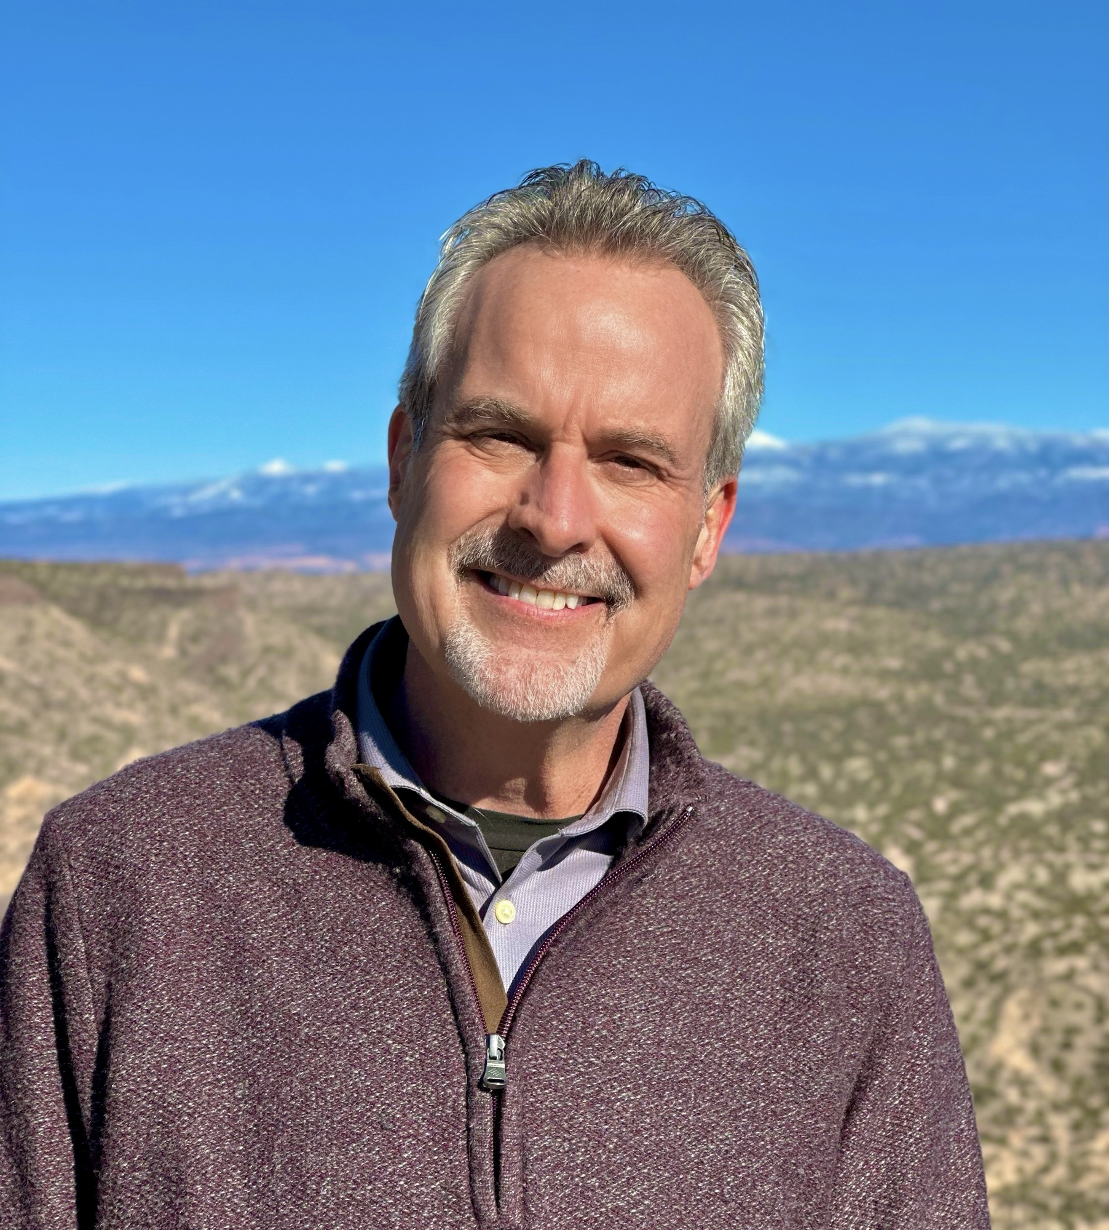

From Project Y to the Present: Los Alamos at the Intersection of Science and Circumstance

From Project Y to the Present: Los Alamos at the Intersection of Science and Circumstance expands on the history of Robert Oppenheimer and the Manhattan Project and chronicles the role of the nation’s premier global security and scientific research laboratory throughout the
decades between World War II to the present.

Dr. Moore serves as the Executive Director of Los Alamos National Laboratory’s Bradbury Science Museum and the BSM Group Leader under LANL’s Community Partnership Division. As LANL’s only publicly accessible space, the museum plays a critical role in communicating the
laboratory’s national security mission and its extensive scientific history from the Manhattan Project to the present. Prior to joining LANL in 2024, Moore served as Executive Director of New Mexico Historic Sites and the Chair of History and Heritage for the New Mexico Department of Cultural Affairs (DCA) overseeing the New Mexico History Museum, the New Mexico Museum of Space History, and the New Mexico Farm and Ranch Heritage Museum.
After growing up in Los Alamos, N.M., he received his BA degrees in History and Political Science, as well as his MA in History from New Mexico State University, and received his PhD in History from Arizona State University with specializations in Public History, 20th Century United
States Cold War, American West, Civil Rights, and Urban history. From 1998 to 2016 Moore directed the graduate Public History program at the University of West Florida. During his tenure, he served an ASEE/NASA Fellow at Kennedy Space Center and conducted a range of projects including those for the United States Navy on Cuban exiles and commuters at Guantanamo Bay Naval Base, the National Oceanic and Atmospheric Administration on
Hurricane Katrina’s impact assessment on Gulf Coast fishing communities, and interpretive endeavors and policy reports for the Minerals Management Service, the National Park Service, the Smithsonian Institution, and others. Moore is a past president of the National Council on
Public History is an NMSU Distinguished Alumni of the Year (2013), and was the 2007 Carnegie Foundation-CASE U.S. Professor of the Year for the State of Florida.

MEETING DETAILS

This month’s meeting will be on Tuesday February 18th. We will meet in the Los Alamos Research Park building room 203A. The building is labelled Hot Rocks Café in the map. The meeting will begin with a social period at 6:00 PM followed by a brief business meeting at 6;30 PM. There may be a presentation starting at about 7:15 PM.

The Military Order of the World Wars meetings are open to all interested people for dinner and program with RSVP, or the program only at no cost. The cost for dinner is $25. Please call Robert Hull 1-505-328-1502 for reservations. A reservation is a commitment to pay. The dinner menu is TBD with appropriate sides.

The meeting will be a hybrid session including Zoom online. Zoom session will start at about 6:00 PM. Zoom details will be in the reminder email several days before the meeting.

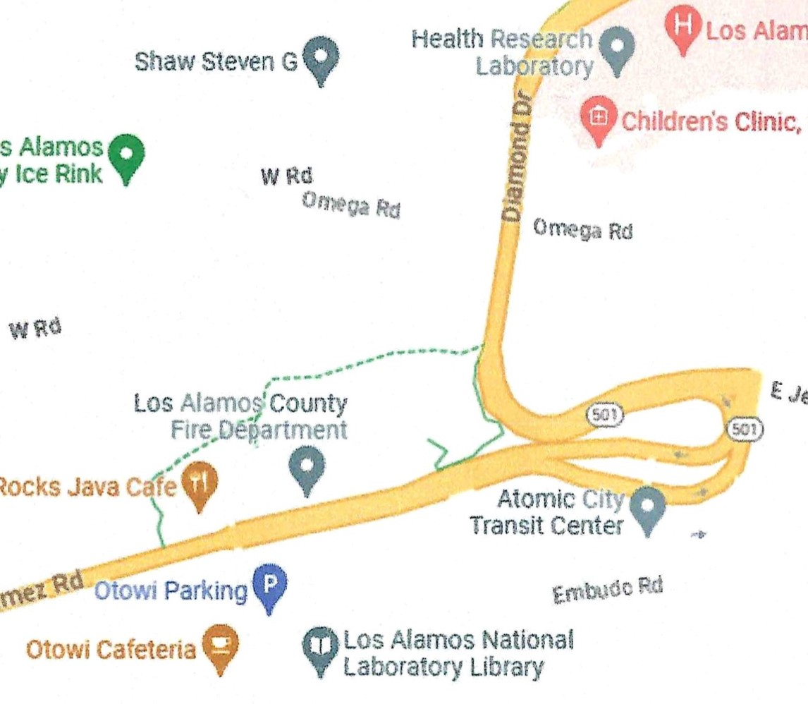

LAHS NJROTC news

This is LAHS NJROTC monthly newsletter March edition. Our cadets have been putting in tremendous effort both in and out of uniform! Recently, they dedicated their time to supporting our local LA Cares by organizing a food drive, helping collect and distribute essential items to those in need. Their commitment to service didn’t stop there—our team also competed in a drill meet in Santa Fe, showcasing
their discipline, precision, and teamwork. Now, with the state drill meet just around the corner, they’re training harder than ever to represent our unit with pride. Their hard work and dedication continue to make a lasting impact in both our community and on the drill floor!.


c/LTJG Melanie Weekley
LAHS NJROTC PAO

.

IN MEMORIUM

It is with heavy hearts that we have to announce the passing of HPM Barbara Jean Wilson.



BARBARA JEAN WILSON 1935 – Jan. 18, 2025
Barbara Jean Wilson, born 1935 on the Navajo Reservation near Gallup, NM, passed on January 18, 2025.
Barbara’s parents brought her from Santa Fe to Los Alamos in March of 1943, where her father, George Hillhouse, was in charge of the meat department of the Manhattan Project Army Commissary. Her mother, Dorothy Hillhouse, became one of the early teachers at Central School.
Barbara graduated from the Los Alamos Public School system in 1952. She earned a B.S. in Elementary Education in 1956 and an M.A. in Elementary Psychology in 1957, both from Colorado State College of Education in Greely. She taught fourth grade at Mesa Elementary and sixth grade at Canyon School, both in Los Alamos.
In 1956, Barbara was chosen to represent Los Alamos County at the NM State Fair as the first Los Alamos Rodeo and Fair Queen. She also showed her trick pony, Tony, during rodeo performances here in town. Her family was known for riding Tennessee Walking horses and organizing the annual fall horseback ride and breakfast at Guaje Reservoir.
Barbara met her husband, Norman Wilson, in Los Alamos. After they married in 1959, she left the teaching profession to raise their three children. Barbara’s philosophy was that parents need to support the activities their children become involved in, which included Boy Scouts, Girl Scouts, the Danville Amberjack Swim Team, the Lutheran Church (teaching Sunday School and Confirmation classes), and volunteering at the various schools the children attended. When the children entered Jr. High, Barbara began several years of substitute teaching in local elementary schools before taking a position with LASL in the Bradbury Science Museum, where she served until retirement in 1991.
Barbara’s interests were wide. Horses were always a central theme. Needlepoint and sewing crafts were also a favorite, and she taught several classes for a local yarn shop in the White Rock Shopping Center. Dog training and rescue became a big part of her life in later years, where Barbara, Norm, and her daughter Sandy rescued dogs of the Keeshond breed for thirty years through their organization Karing Keeshond Rescue. The dogs, wearing their little red cowboy hats, were a favorite during parades in town. About 50 Keeshonds were rescued and found forever homes due to their efforts. Barbara, Norm, and Sandy also taught dog training in Los Alamos and the Santa Fe dog clubs. Most recently, Barbara served as a docent at the Los Alamos History Museum, where she enjoyed sharing her experiences of early Los Alamos with visitors.
Barbara is survived by her three children, Sandra (Mark), Scott (Anne, and grandson Alex), all of NM, and John (Patricia) of CO.
She was a local member of the United Church, Los Alamos Historical Museum, and Community Bible Study, teaching and participating in discussions. Barbara was also a member of the MOWW (Military Order of World Wars), Los Alamos Chapter.
A Memorial Service will be held at the United Church of Los Alamos at 10:00 AM on Saturday, February 22, 2025.
In lieu of flowers, Barbara requested that donations be made to the United Church Memorial Fund or to the Los Alamos Animal Shelter.

FOR THE GOOD OF THE ORDER

You have received the email with the request from the Nominating Committee for companions to be nominated to fill the national elected officers and a copy of the MOWW Recruiting Guide. This is your chance to run for a national office and an aid in recruiting new companions.

The Region XIII Winter Conference was held at the Desert Rock Hotel and Casino outside of Tucson, AZ January 16-19, 2025. It was similar to the planned 2025 MOWW Annual Meeting with participation by the CINC and tours and other activities similar to the annual meeting. The business meeting was held on Saturday morning and was a hybrid meeting on Zoom. It was recorded.

The CINC and Chief of Staff were present. Items of discussion included chapters being at least 75%veteran membership to comply with the IRS 501©19 requirements, Chapter Action Plans (CAP) being based on Annex B of the Strategic Plan, and what each chapter is doing and how well related to their CAP, The deficit in the Order’s budget was discussed including the use of investments to balance it and support the annual dividend. Providing business cards with the Preamble on the back was discussed. Volunteers for the America 250 Ad Hoc Committee were requested.

The 2025 Annual Meeting will be held in the Desert Rock Hotel and Casino outside of Tucson, AZ. Since this meeting is “local”, all able members of the chapter are encouraged to attend. In 2026, the meeting will be held in the Weston Hotel along the River Walk in San Antonio, TX. The 2027 meeting will be held in Gurnee, IL north of Chicago and near Great Lakes Naval Training Station.

The Order has a new trifold brochure describing MOWW’s ROTC and JROTC Award of Merit Program. I have copies if you are interested.

Once again, it is time for the CINC’s Solicitation. The money collected is used to support many activities through the Order. Please donate generously to this solicitation.
NATIONAL OFFICERS

- COMMANDER IN CHIEF
Lt Col David J. Worley USAF (Ret)
worleymoww@earthlink.net

- SENIOR VICE COMMANDER IN CHIEF
Lt Col Marlon Ruiz, USAF (Ret)
ruizmarlon08@gmail.com

- REGION XIII COMMANDER
LTC Ken Robinson, USA (Ret)
Robinson4ken@gmail.com

Region XIII website www.MOWWSCV.com

NATIONAL STAFF

- CHIEF OF STAFF & COO
Col Michael Farrell, USMC (Ret) | chiefofstaff@moww.org

- DIRECT OF FINANCE
finance@moww.org

- MANAGER, MEMBERSHIP PROGRAMS (including dues payments)
HPM Justin Hiller | membership@moww.org

- MANAGER, MOWW STORE
Mrs. Sunny Alley | merchandise@moww.org

Website www.moww.org

MG MILES CHAPTER OFFICERS

Commander
LTC Gregg Giesler USA (Ret)
Home: 505-662-5574
g.giesler@computer.org

Senior Vice Commander
MAJ Robert Hull USAF (Ret)
Home: 505-662-7950
rhull@lata.com

Adjutant
HPM Robert Malone
Home: 505-672-0248
Robert_malone2@aol.com

Treasurer
MAJ Robert Hull USAF (Ret)
Home: 505-662-7950
rhull@lata.com

COMING EVENTS

March
10 Staff Meeting
18 Chapter Dinner – Patrick Moore – Bradbury Science Museum

April
7 Staff Meeting -
15 Chapter Dinner – Christine Chandler - Legislative Session Review
NJROTC Awards Ceremony, Smith Auditorium

May
12 Staff Meeting
20 Chapter Dinner – Alan Carr –
26 Memorial Day Ceremony – 11:00 am Gauje Pines Cemetery

June
9 Staff Meeting
Region XIII Conference Hybrid 9:00 am
17 Chapter Dinner & Elections/Installation of Officers
28 1994 Chapter chartered

MOWW SOCIAL MEDIA

National Facebook Page
https://www.facebook.com/MOWWnational

MOWW Facebook Group
https://www.facebook.com/groups/militaryorderoftheworldwars

MOWW Instagram
https://www.instagram,com/mowwhq/

LAST MONTH: SPEAKER

The speaker at our February 18th meeting was Dr. Glen McDuff.

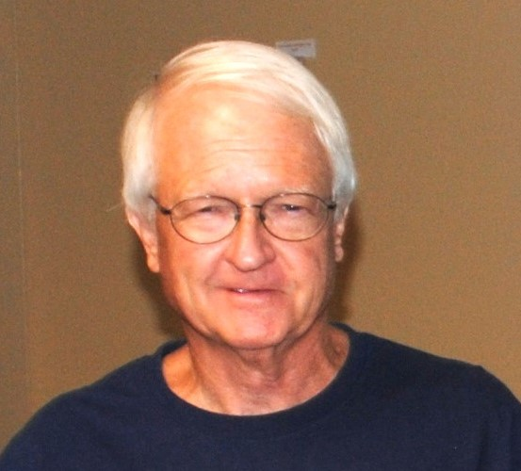

Ballistic Missile Defense

We were talking about ballistic missile defense. Let me just give you some of the numbers, because you'll find out that the military is not the best at keeping track of things. You get a lot of discrepancies on the numbers of weapons, systems, and all. Our first ballistic missile is Quiz. When was the first ballistic missile. Anybody want to guess? It was 1800s. All right, and wrong. No? Do you play on this one again? That's right, two, three thousand years ago. This is a ballistic missile where they invented the trebuchet. Ballistic missiles are exceedingly hard to defend against. That's why they're so popular. It's been around quite a while. Hit it one time. The first real modern ballistic missile was in 1944. That was a V2. Even in fact then, you have velocities of like five kilometers a second. It's just like 5,000 miles an hour. These things are going to be screaming in. These are some wicked, wicked. So, the Brits determine from the V2 attack they have about 25 seconds to detect the V2 and target the V2, and what's the interceptor? One time. They were smart enough just to say, we give up. That we're not even going to try and waste time trying to defend against them.

After the war, we started looking at ballistic missile defense because we now own practically all the German rocket scientists and almost all the German rocket hardware, which is all about my science. So, they called Project Wizard. We thought that we were going to be able to build an defense in a couple of years. Well, we frequently realized this is not the case. So, on a scale from one to ten, I rated technology we were working on, like atomic weapons, about two. Not too hard. Rocket development is hard. It's rocket science. I'm seven. The mission to the moon, I would rate it ten, and missile defense is 165. We learned right off the bat, this is going to be a tough problem. So, even by the mid-60s, actually up until the 70s, we had no defense against even a V2 rocket. That's how hard this was.
There's several efficiencies in technology that we really were missing. The first was radar. We had good radar, but we did not have good enough radars to track these high velocity ones. The biggest, and probably still in one of the biggest limitations is computing. Computing power required to do targeting a ballistic missile is horrendous, especially when you're dealing with an enemy, and we'll say a lot of that in a little bit. Targeting, which is basically based on instant data into the computers to calculate how to respond. Again, it's a computer limitation, and then you have to have a rocket with agility and speed faster than the incoming ballistic missiles. So, if you have incoming ballistic missiles that are in the Mach 6 to 12 range, you have to have a pretty serious interceptor. Oh, that's fine. But what could we do? Well, while we were looking at missile defense, somebody said, hey, we still have airplanes to worry about in the 50s because we don't really have rockets yet and they're coming, but we have an airplane to view. So, we started looking at air defense. In 1963, we had spent almost $800 billion in developing air defense, and we had air defense. We did really good.
-
In the final system, we had over 300 radars, land, sea, and air. We had 24 what they called direction centers, called DCs. These would be places where computers would be to do calculations and analyze the incoming data at three combat centers, which I'm not exactly sure what the three combat centers did. I'm not sure if anybody else knows either. But all of this came together in what they call this semi-automatic ground environment system, or SAGE. This was our first big attempt to find what would become ballistic missile defense. SAGE is the entire system of early warning radar. The radar would automatically transmit information to the direction center of information on the incoming airplanes. Speed, altitude, direction, all that stuff. They would be processed automatically at the direction center, which would then notify air bases of where we need to defend, headquarters, missile batteries, the air defense missile. Data would also be relayed to other direction centers that might be in the path of, or in case the bomber took a different route, all adjacent direction centers. Direction centers would automatically calculate the path, target, and then deploy aircraft fighters to intercept the incoming bombers. And it would immediately fly out and meet the evil commie bombers coming in and hopefully shoot them all down.

These places were among them. The data center would be in these gigantic, huge, three-story cement blocks with a computer that had 256K of memory. Typically, the computing system had 120,000 12AU7 vacuum tubes, each running at about two watts. Well, which exhausted about 6 megawatts of heat, and the center in Oklahoma, they actually took all the heat from this building and heated the rest of the base. They just circulated the waste heat from the data center. All the radars that go into these centers, you can see in this map, all these little dots are radar systems, and these little squares, I don't know if you can see this, these little squares are the areas of which this radar system would watch. All these different segments would transmit data to the data center. They would process everything. There's a picture of inside one of the data centers before it was, they're actually all gone now. This is 1960s.

These giant big building. A lot of these buildings, they have now converted into SCIFs for the intelligence community. It's basically a giant three-story building with a door. Travis Air Force Base, they have one of these things going. They actually designed it so that it looked like it had windows, but they weren't, they were fake windows because they didn't want people to know what that building was, and the walls were almost three-fifths thick. I think this one is now the SOCOM operations at Fort Bragg. This is SAGE. These were very impressive.

They would do the incoming airplane, they'd take all the data in, calculate basically a firing solution, deploy aircraft, and you'd go out and shoot the bombers, and it actually worked really, really well. And the reason is Soviet bombers always flew about 300 or 400 miles an hour. So you've got the time.

So what all of this came about, this is on the kind of the nuclear side is in 1953 Special Weapons Development Board or committee determined that we needed about 40,000 air defense missiles to defend against the Soviet. So later that year, for several other reasons, Los Alamos had already been looking at this issue, the big problem was 40,000 air defense missiles, most of which are nuclear. Nuclear weapons at that time took a lot of service to maintain a ready state of the standard issued weapon back then took hands-on service every 72 hours. Well, if you just add 40,000 weapons to the stockpile in each service every 72 hours, you have a big problem.

So what we did, or when General Fields came to Los Alamos and said, there's three things we want. We want a warhead with an infinite shelf life. We can't have this service every other day, and once it's made ready, it can stay ready for several months so when we deploy an aircraft with a nuclear weapon, we don't have to come back in two days. There's one quote that actually stuck in the meeting was “as much maintenance as the block of pine”. So Los Alamos introduced later that year, because we knew the servicing thing was not working out, a three-year weapon, our first sealed-pit weapon that had a three-year shelf life. It's so close to infinite and pretty close. So it could typically stay ready for three weeks. That means once they were activated, the batteries would last three weeks before getting to change batteries. And when they came to you, there was actually no service on it. The weapon would be delivered to the military. It would be put into the missile. It would sit there for three years. If they would come out, a new one would be put in its place, and that's it. The old one would be recycled. They were called the wooden bombs. So if you ever see in old literature or history, the wooden bombs, this was the first of that.

They went into air defense missiles. Now, we were very serious about air defense. One reason, we were very successful. The ability that we had, to give you some idea, Nike Hercules, 25,000 missiles, Talos, 1,500, Bomark, 570, Genies, 6,000, Falcon, 26,000. Honest John is not an air defense missile, but talking to several of the guys who manned Honest John nuclear squads said we would shoot at airplanes if we wanted to. Because we're the Army, we'll shoot at anybody. So, tell us through that process. That's where the big growth in nuclear missiles came. You always hear on TV about America has 50,000 nuclear weapons. Most of those are these little low-yield air defenses. Most of these are very low-yield air defense nuclear weapons. So, what about missile defense? Well, here's our timeline. We started, just kind of out of nowhere, based on the Nike Hercules air defenses, so we had Nike Zeus. It was our first attempt at ballistic missile defense. That turned into Project Defender, which then kind of waffled along for several years. It then became the Sentinel Project and the Safeguard System. That's the Stanley Mickelson Complex. It's for sale right now. After that, we had the Strategic Defense Initiative, which died and became BMDO, the Ballistic Missile Defense Organization, which then changed into the Defense Support Program and currently is a space-based infrared system.

This is where I came into the picture in Star Wars. I actually found one of my participants, one of the joint, cooperative, DOD, UK-based things. I was a program manager in Star Wars. Now, we have sound, because this is a movie coming. We're here with a variety.

“I call upon the scientific community in our country, those who gave us nuclear weapons, to turn their great talents now to the cause of mankind and world peace, to give us the means of rendering these nuclear weapons impotent and obsolete.” [President Ronald Reagan]

That was the Star Wars. That was the famous March speech. So, our very first success with the Nike Zeus, very similar to Nike Hercules, if it was like its brother or sister. The way this works is, every launch a missile. We have an acquisition, everything's on the ground at this time, acquisition radar. Now we go to the Zeus DC, which is a separate entity, just for Nike Zeus. That would start calculating. They would then have discrimination radar, which in this case, there was nothing to discriminate against, because there was one warhead. But in case there was other decoys and more than one warhead, this was supposed to pick out the real one. They'd have the target and track radar. It's very similar to a Navy system. That would go, again, to a targeting computer, which would calculate a firing response, which would then launch the intercept missile, which would then basically be a beam rider. It would know where the warhead is, and this would follow the beam out and hopefully hit the incoming warhead. That's the system.

Well, it actually worked. We actually shot down an ICBM in the early 60s. The Nike Zeus is really effective against one warhead. If there's one missile and one warhead, Nike Zeus is pretty good. The problem is, with the advent of multiple warheads, MRV, not independently targetable, just three warheads on one missile. When you add three warheads to a missile, you drop your chance of kill from, like, 95%, 98% to zero, or maybe 1%, anyway. So it really kind of just makes this whole thing mute.

“In 1962, an experimental Nike Zeus missile succeeded in intercepting an intercontinental ballistic missile for the first time. The Nike Zeus was the first step in America's anti-ballistic missile program. By the late 1960s, Nike Zeus evolved into the Sentinel program. Sentinel used two missiles, a long range missile attacked outside the atmosphere. The smaller Sprint missile then attacked any missile that penetrated the Spartan barrier. The Sentinel ABM program was a technological marvel every bit as challenging as the space race to the moon, but military thinkers became concerned about what ABM missiles meant in the Cold War relationship between the United States and the Soviet Union. There were fears that a ballistic missile shield would mean both side would build more and more offensive missiles to overcome the defensive barrier. As a result, in 1972 both sides agreed to place very strict limits on the number of defensive missiles in the ABM Treaty. In 1974, the United States deployed missiles in a single site in North Dakota as part of a small, limited network called Safeguard. Safeguard would provide a limited defense against a small attack and it was closed as uneconomical.” [video narration]

That's how the old Nike Zeus either ran into political problems or money problems and so it evolved into this. Also with MRVing, you can't shoot one missile down. You need three, you need nine missiles to shoot down one missile. So it becomes very inefficient cost-wise. So the whole Sentinel program is kind of like the old game Space Command where you shoot a nuke to destroy a nuke. So now you don't have to hit it. You just have to be kind of close. That's the whole thing behind Sentinel.

It had, our only system was in North Dakota and that's it, the Stanley Nicholson Safeguard Complex. It had two missiles, the exo-atmospheric Spartan, and the endo-atmospheric Sprint missile. Both of these are nuclear. Spartans would be shot to intercept in space, primarily mid-course. Sprint would be shot as the last is terminal defense. The target would be in the 20 to 40,000 foot range and blanket, the area with radiation. What ICBM did the Nike Zeus shoot down? It was, it wasn't really an ICBM, it was just a fake missile. That's another thing. We're talking about that, but since you brought that up. These tests are not like somebody shot a missile just out of nowhere. Most of our missile tests are two years in the planning and they wait for a nice, calm, warm, sunny day with no clouds, no sunspot activity, and everybody had a nice breakfast and it well rested, and they know where the missile's coming from. They fired it from Vandenberg and intercepted it at Kwajalein. So when they, if you sent one up to intercept it in space, then like you were talking about the last time, we talked about the effects of nuclear weapons. So there's no pressure wave, right? No, no pressure wave, it's all radiation. So the kill up there is a radiation. You'll see that here in a minute. In fact, both of these, this one, if it's really close proximity, will have a pressure wave, will have pressure kill. But most of it's radiation. The radiation will reach farther.

“It became clear that threat sophistication had evolved to a point where some warheads because of their accompanying debris and decoys would not be distinguished in time to be engaged by the long-range interceptor, a close in terminal defense it needed. The answer, a new missile called Sprint. It would be so fact that it could rise to a successful intercept even if launched at low altitude aerodynamic target discrimination. In flight, Sprint would become incandescent. Its development required major technological breakthroughs. Sprint is gas ejected from its underground cell. Because of its very high acceleration rate, it is built to withstand unprecedented g stresses. Sprint was developed by the Martin Marrietta Corporation in Orlando, FL. Special coating materials dissipate heat as they oblate thus limit temperature rise to missile structure and components. Several flights were conducted at White Sands. Not all were successful. It was after all, a missile whose performance requirements presented staggering demands. However, recovery and examination of flight hardware revealed causes of failures. Isolating and correcting the defects led to a series of spectacular successes. The MSR is capable of controlling Sprint missiles located as far as 25 miles from the radar to provide greater area coverage. These sites contains only Sprint missiles which are launched and guided via communication links with the MSR. The interceptor warhead needs only to be detonated in the vicinity of the threat to neutralize it. The reentry vehicle comes in from the right. The intercept is repeated in stop motion. Because of its speed, the incandescent reentry vehicle appears to be elongated. These exercises demonstrated the system’s ability to control Sprint interceptors launched from a remote location. The 150 intercepts with tracking data mission were conducted with about a 90% success rate. The last 21 missions were completely successful. During the entire Kwajalein effort, most of the missions were observed and recorded by personnel and equipment on Russian ships. The Soviet Union thus stayed fully aware of the progress and success of Safeguard tests and Sprint. “ [video narrator]

Those are real time, but these aren't sped up. You hear all this talk today about hypersonic this, hypersonic, they're hypersonic, and they're actually guidable hypersonic. Also, a lot of the tests at Kwajalein were delayed so that the Soviet spy ships could get close enough to get really good pictures of the tests, so we wanted to be sure we knew what was going on. Unfortunately, they bargained all this away. The Stanley Nicholson Complex, which achieved site readiness in April of 1975, became operational on October 1, 1975. It was fully operable with the radar, the whole nine yards. On October 2, that House of Representatives spoke to decommission the base. Less than 24 hours after it became operational, the 3rd of October decommissioning began. In February of the next year, the whole base was closed. Just to show you.

Now, this is the unclassified stuff you can talk about. The Spartan and Sprint interceptors were planned, originally planned, to have four sites across North America to defend our missile fields in Missouri and Montana, along all the missile fields. Missile fields are basically targets for Soviet missiles. The Cannikin device nuclear test in Alaska, was actually the test of the Safeguard Spartan warhead as part of the exo-atmosphere. The long-range interceptor was, which was a high yield device, killed by x-ray. The x-ray enhanced basically to use x-rays to destroy the warheads in space, where you don't have any attenuation of x-ray. So that's fine. That was x-ray enhanced. And then Sprint is just very low yield, fast, and it would kill the incoming warheads as a light terminal in their terminal phase, basically with neutron, which would penetrate and just destroy the electronics. That's what the Safeguard system would work. This has a high probability of working.

So we went on to SDI, and we're talking more about SDI, but there's kind of five things in building a missile defense system, because we haven't built a missile defense system since. First, advanced warhead. That's searching, acquiring, and tracking. This is probably one of the easiest, is detecting advanced warheads. Then it starts to get harder. Discrimination. What you have to do when they send a missile up, the send warheads and they send decoys. They also send the junk that came with the rocket. They can have 20 to 200 pieces of garbage flying with your warhead like all the pieces of the third stage, the fuel tank of the third stage. All this travels with you in space. All this travels on a ballistic trajectory. We have to have surface systems targeting the warhead and guiding the interceptor. That’s pretty hard. Command and control is coordinating all the inputs from all the different radars, and then we have to have a bullet. These are ballistic missiles. These are not any ordinary antiballistic missile. They need to be steerable. They need to be exceedingly high velocity.

Step one. We need advanced warning. These are over-the-horizon radars. We would look for things coming through space, also airplanes, but primarily warheads. We then started using satellites, Defense Support Program. They are called DSP satellites. They use standard radars. These were about 60 of them. They used standard radars and looked primarily at Soviet missile fields or where we think Soviets have mobile missile launchers. They would detect a launch. Launches are exceedingly easy to detect because when a rocket goes off, there is an exceedingly big heat flash. This works pretty good. The next phase after radar, we went to the space-based infrared system which now consists of 6 geosynchronous satellites.

“Global persistent infrared surveillance continues to be a critical national security space mission. The Cold War focus on strategic ICBM systems has been expanded to include short and medium range ballistic missile threats. The Defense Support Program maintains the legacy Cold War monitoring to warn of ICBM launches against the US. The replacement program is the space based infrared system or SBIRS which has already provided two infrared-sensor-loaded payloads in highly elliptical orbits or EO and the SBIR program has also deployed multiple spacecraft in geosynchronous earth orbits or GEO. Each has two independent infrared sensors. One is a scanner dedicated to missile warning with full earth monitoring. The other sensor is a taskable starer that can focus on selected regions. Each pair of sensors act simultaneously and independently of each other providing a robust taskable infrared platform. SBIRS is the next generation of space based programs. The program has already proven its value with successful EO payloads on orbit. With deployment of the GEO spacecraft, SBIRS will be an unprecedented resource with the nation's global, taskable, and persistent infrared monitoring sentinel.”. [video narrator]

Now, the way these work is kind of infrared sensing, and they have two infrared sensors. One, a broad scanner, which basically covers one-third of the Earth's surface at any one time. The second one is basically two-to-one. So if you think the Soviets, or Russia, or Chinese, or whoever, are having special activities with suspicious activity, they can just go and look. It's steerable. They get really specific data, and right now, I think the system now is fully operational.

That's just discrimination. How sensitive are they to an EMP? Oh, that's a good question, and the Air Force would like to know that, too. We haven't tested a single satellite against EMP since 1991. For anything in space since then, we have kind of estimates, but for those things. I'm not betting money. NASA has some satellites that measure EMP, but it's only because of the solar stuff that they're looking at. Not a nuclear EMP. But discrimination, now, this is a really, really hard problem. We have sea and land-based radar. Look at standard radar. The higher the frequency of the radar, the better the discrimination. We only have ground-based radar right now. We really need space-based radar than LIDAR, which is laser radar, which works on the same base in principle. Instead of reflecting microwaves, it reflects photons. LIDARs are exceedingly well-developed. The reason you want to go in space is there's nothing in space. So you don't have any distortion of the beam. You're way low-powered. You don't have any attenuation of the beam. You don't have to worry about clouds or rain or hurricanes or stuff like that. Also, in space, you have a much greater field of vision. Like the SBIRS satellites, looks at about one-third of the Earth's surface, one radar. And this is in very important for tracking the third stage. If you have a wide field of vision, you can track it from third stage to warhead deployment over the long period of the mid-course.

Now, the answer to the intercept of target surface guidance is most everything we do is beam riding. We're looking at the incoming target, and our missile is going to follow the beam out, too. Beam riders have limited agility, though, because they're following a radar beam. They don't know what's in front of them. Well, if there's a bunch of junk, that's one of the problems of having decoys and extra parts of the spacecraft flying with you. It may hit something before it gets to the warhead, and that's a big issue. That's why discrimination is very important. This takes horrendous computing power, especially if you're trying to discriminate from one missile, say, several warheads, four, five, six, two, and 300 pieces of other stuff flowing with it, and you have to pick this out. It's a really big problem. In a complete launch, you may be looking for a warhead in over 100,000 reflections. So, it gives you some idea of the computing you've got to have.

So, the sense of the way this works is we have space-based radar, close-in radar, over-the-horizon radar, tracking radar. We have several scene-based radars, and then what they call the close-in radar. That's the last-ditch targeting radar that basically plays very closely for your missiles are. Then we have, and all of this has to be coordinated during the boost, the midcourse, and the terminal range, and we're going to look at all three of them.

Command and control, this is all the stuff you have to coordinate. Currently, we have the AN/SDY-1 radar, Cobra Dane, which is an Alaska Aleutian system, which is still operational. We've probably seen it in movies like the old DEW line in the Arctic. That's Cobra Dane. We have the command and control battle management center. That's probably a direction center. We have the Defense Support Program. That's the original detection satellite that will be sending in information. All of this report will be calculated with the high velocity missile, fire control for the high velocity missile, the ground base interceptor missile. We have the long range discriminator radar, which will be feeding information on the sea-based radar, the space tracking and surveillance system, the space base infrared system. The TPY-2, that's the close-in radar that can be feeding information, and our new upgraded early warning radar. Now, to use some idea of what this is like, I thought it was kind of a good analogy. Say you're going to balance your checkbook. You have your checkbook and your statement. Okay, I'm going to balance it, so you start to balance it. The problem is, ten times a second, you get a new check and a new deposit. Every second, you've got ten new entries that you're trying to reconcile while you're doing your, okay, well you can't do that. You can't balance the checkbook if your input is changing faster than you can reconcile with, and that's what this is. This is a lot of data because all these radars are giving velocity, direction, altitude, attitude, all sorts of stuff. Some of them will be giving estimated mass and proposed trajectory assuming that they don't have some sort of steering capability. This is the killer of the problem. Even with today's high speed computers, we can't do it. That's why. It's just way too much information.

Now, the anti-ballistic missile, currently we have three. We have the Patriot Advanced Capability, that's the Patriot missile. They made a big splash. We kind of discovered Patriots can shoot down missiles at the first Gulf War. We have THAAD, the terminal high altitude missile. We have the Aegis system, which have three different missiles. We have got a medium, an immediate, and long range missile. Then we have the ground-based mid-course defense, which is a kinetic kill vehicle. We're going to see all three of these. The first one is the Patriot. It's a ground-based advanced capability. This actually has some chance of shooting down warheads. It's in the terminal phase.

The THAAD, this is a terminal phase, maybe mid-course, but this actually shoots way. This can actually go exo-atmosphere at the terminal. There are basically a lot of things in the news. Oh, this doesn't work. They did another test, and it failed. They did this test and blah, blah, blah. These get a lot of bad print. They work actually a lot better than you read about in the press. I told in Annie's book, because she talked to one of the generals, and said, yes, it’s a pile of crap. Well, no, it doesn't do what you want it to do, but you're trying to solve an impossible-to-solve problem. They actually do a pretty good job, which is not good enough, but it's a pretty good job. It's not enough of them to combat all the incoming? It's kind of like on the US movies, where the spartan goes out with his sword, and all of a sudden over the hill comes 10,000 soldiers. Okay, I'll get a few of them.

At Aegis, we have 33 Aegis cruisers that have Martin missiles, and we have one ground base in Hawaii, which can launch towards the Pacific. The Aegis missiles have been improving. The first ones, like the Model 1A, had a kinetic kill vehicle with 2A, and we're up to this one, the standard missile 3, the 2A, that's the latest missile. This is an actual atmosphere that actually has a kinetic kill vehicle. I mean, it launches a little rocket that flies and actually hits the warhead, or a bus. That's what it kind of looks like. It's a big rocket engine. This rocket goes, it's an actual atmosphere. You track the incoming bus or a warhead, and this thing launches and flies and actually hits, I mean, they go explosive to it. Does that always neutralize the warhead, or can it cause criticality? Does it hit a warhead with a BB in space? That will knock it off the course. Of course, but does it neutralize the capability of going critical? It's a kinetic weapon. It's basically a bullet. Again, it has a lot better success than I would have made money next time. A kinetic kill is actually a bullet next time.

So, kind of the way this works is, one of the problems with detection is to get a lot of good information, you need to be really close to where they launch. Well, if you're in the middle of Russia, you're five time zones away from the closest place you can put a radar. So, you usually have forward-based radar, like the AN/TPY-2. Launch, it'll say something has launched. We'll have the other radars looking at it in space, tracking. We'll have the mid-phase, and then in the terminal, you'll have some sort of terminal-based radar. That's kind of like the last-ditch effort to get really accurate information to launch a THAAD, and this will be fairly high altitude. This is, you know, 100,000 feet. It's kind of space, because I don't know, depends on who you talk to, we're space starts, but, it's like 100 to 300,000 feet-type altitude. And that's the whole fantasy. Now, somewhere here, we can launch the kinetic kill vehicle, but it's exo-atmosphere.

Now, the tricky part. Boost phase of the rocket. Very quick, one to five minutes. It's really easy to detect. In fact, it's almost impossible to hide a rocket launch from any rocket detection system. The problem is it's really short. If they launch a missile in the middle of China, and we detect it by the time that we can say launch this launch, or you can tell a missile cruiser has launched, it calculates the firing response, the missile is already gone. So that's the part. You have to be really close to the launch site to have a really high probability of kill. Mid-course is the most vulnerable time. This is 10, 20, maybe longer, 10, 20 minutes. That's just where the third stage and the bus is basically in a trajectory in outer space. This is part of the, this is what I just wanted to share. The problem here is not so much tracking. We can track very, very accurately. It's discriminating because what they do is everything you launch into space is still with the warhead. The best example is back in 1958 when they launched Sputnik. You could see Sputnik flying over San Francisco, the big headline. No, you don't see Sputnik, because Sputnik is a little ball about this big. What you saw was the third stage that launched the ejected Sputnik, which is still traveling right behind Sputnik. It's huge, so you could see that. Everything that traveled was a third stage, and that's like heat shields, warhead cover, fuel tank. This could be hundreds of pieces, and this could be a lot of big pieces, and somewhere in all that garbage is a warhead. But to make things worse, and this is what killed us over and over, this is so easy to make countermeasures. One of the killers is the little metal stamps. They basically, I think, take old gun wrappers with the foil in it, chop it up into little pieces and just sprinkle it everywhere. So you have thousands of little aluminum pieces flying, or the reflective powder, Scotch brite. There's stuff they put in road signs and license plates to make them reflect. It's a little powder. You cut that out, you shine a laser into it, and it reflects the beam in a million directions. So we just built a billion-dollar discriminating laser. It can not only discriminate between decoys and warheads, it can pick out the real world. It can determine mass of an object, rotation, velocity, direction, and vector. They can do all of this in a few microseconds. I tell you, you puff out a little Scotch brite, and now it's all for nothing.

This is one of the worst, and it's no big secret, decoys, because here's a patent on decoy-deployed ICBM warhead, and this is what they look like. The museum used to have one of these. It's plastic, and it inflates in outer space. In outer space, a balloon and an anvil will travel together. There's no difference as far as space goes, and they even have a radar on the end of it. So it's sending out a signal like a real warhead. So if you have a discrimination radar, like an S-band, you'll see the shape. You can see that it's transmitting. You think it's real, because you don't go with the mass, and you don't know it's full of air. They're made out of trash bags. The museum had one, and I think, got all dried out as a trash bag. But you can load up hundreds of these on a warhead to deploy just one warhead, not be traveling with a hundred of these things. So now you've got a hundred items that look just like the real thing.

Terminal, and that's a good term. This is pretty well the end of everybody. It's very short. Typical velocities are somewhere between Mach 8 and Mach 12. So these basically last five to eight seconds in the terminal phase. You have to have a really fast rocket to shoot something down that's coming in at Mach 12. Really fast rocket. That's not nuclear. That's why the Safeguard System is so good. We know they're coming. We know about what they're going to be here, and we can show a fire nuke in front of them. So they pass through the radiation and die. That's why those type of systems work really good. Currently, we have very limited midcourse. That's basically the kinetic kill vehicle, and we have extremely limited moves and terminal events. We don't have missiles right next to where the Russians or the Chinese are going to launch, and we probably can’t hit something coming in at Mach 12 anyway.

You know, actually in those Aegis, the ships that you talked about that we had in the Red Sea, so when the Houthis were setting off the missiles, one of them actually, we weren't able to shoot it down, except with this, I can't remember the name, it's like a Gatling gun kind of thing. It's how they actually shot it down at a distance of, I think it was about a half mile or something, which is really close when you could consider how fast it's going. It's radar guided, but again, it's that ballistic kill. It's spraying out a whole bunch of bullets that's going to have to run through this screen of bullets, and that's what kills it. That's a Soviet strategy they've used for decades. We were developing our new anti-aircraft guns back in the 80s that turned out to be a total failure. The reason we started doing that is we captured one of the Soviet anti-aircrafts in Syria that had shot down at F-15 and like 20 miles away. How did this, I don't know how to describe it, it's like a 1950s technology. Shooting down our most advanced aircraft, and the way it does it, it's got four barrels, that fires 3,000 rounds a minute. They just fired a zillion bullets. Well, it takes one. We were quite sad because they were tested in one day. We didn't even see it, but we were in the cafeteria, and they're laughing, they're just tears of joy they're saying the first time they tested it, it's radar guided, it's got four barrels, super sophisticated. So it turned it on, a drone flying by, it turned around and just destroyed the outhouse that had a fan going in it. It shot it to bits. We got to put in the outhouse fan filter in the software. We had a software glitch there. They were way too sophisticated for the Soviet thing. The whole thing was like made out of spinach cans. Like, how does this, the reason is it shoots a million steel bullets.

So we have very limited, so how would all this work? Let's not say Annie stole this from me, because I did this way before. I say Uncle Kim decides to launch a nuke at America. Can we defend? Well, actually, to be truthful, we really don't know. We have 36 interceptors deployed somewhere. We have four in Vandenberg, we've got 32 in Fort Greeley, in Alaska. We've got eight more of the kinetic kill vehicles coming very soon. This is four or five years, so hopefully they're around. So these are, we did 18 tests, a big whopping 18 tests in 20 years, and we had 10 hits. The problem is, these are scripted tests. They have a ship out at sea, another ship out at sea, they launch a missile. They know when they launch it, because they call it. They're, at 1 p.m., we're launching. Everybody's ready. The seas are calm, the weather is fine. So we have to know one of the generals that Eglin once asked, they were doing it for the war, and I think they had to say it called the war. They said when you come out here, we test these new weapons, like the bunker buster and then all these missiles. And we get a 98 percent kill. They said, but in battle, we get like a 40 percent kill. The pilot said, well, you have to remember, sir, this morning, I've had a great breakfast. I got my baguette, I flew out over the Gulf, I flew around, I fly in to the bombing range. Weather's great. I'm going to go play golf this afternoon, and I hit the target. I go to Iraq, they're shooting at me. You know it's not the same. The weather's bad, the dirt's blowing. They're shooting at me. I do the best I can. So that's, you have to adjust for that.

Anyway, the plan, one warhead's coming in, we're going to shoot four interceptors at it. Four, and that's going to give us a 97 percent kill, and that's probably pretty accurate. Four will do that. Now, that is theoretically. If you start accounting for life, like it's at night, or one of our radars is in maintenance. Oops, we just lost a huge input, or maybe more than one, because there's several hundreds, and one of them may be critical. The sun can really mess with you on this stuff. One big burp out of the sun, and all of this stuff is not going to work. Can have a tornado, or a hurricane, or just cloudy. If you start accounting for all these, effectiveness drops pretty rapidly. There's other shortfalls. The field of view, one of the ground-based lasers is certainly small. As you start adding all this up, our 97 percent drops pretty quick.

So Uncle Kim has like two missiles. He has the Wausau 13, which is one missile and one warhead. This is the warhead, one big warhead out there. He also has this the bad guy, the 14, which has multiple warheads. So he has a heat shield over the top of the warheads, which will be deployed. He has two or three or whatever big warheads they got him. If they have multiple warheads, and this makes things, also they may have added counter-measures like chaff, reflective powders, flakes, and everybody knows this. It's not a secret about deploying junk. So this is going to make a real mess of things.

So, in reality, fortunately, the very infancy of the missile program, hopefully their missiles are so inaccurate, they'll launch it, and by the time we detect where the target's going to be, there's no target there. To shoot a missile 6,000 miles and hit something is not easy. We have worked years and years to make accurate missiles. So his accuracy is probably pretty bad.

So, there's a film clip. The next thing you're going to not do yet, you've got to see, this is a film clip, probably how this would work out. There's the whole, we really don't know how this would work out. Are we going to shoot it down? We could, could we miss it? It's just going to be, there's so many variables.

I think there's something else coming. I want you to put this in there. This task is probably the hardest task that we in the military face. Almost as hard as thorough nuclear fusion, which I think is probably harder. Even with modern computers, we are still limited in calculation ability, and I don't know exactly when we will achieve this. The biggest problem is, and I worked on this, a discrimination laser. We had a discrimination laser. It would work great in space. We could discriminate warheads at like 30,000 kilometers. Well, we had a problem with bearings, but other than that, the theory is irreparable, and it takes it close in, we can do this. A little Scotch brite, a $20 million, $30 million space base discrimination laser is worthless. So, you know, the bad guy can shoot us down with 75 cents worth of stuff, and just break our system. And that is a really, really frustrating .

For you young engineers, if you ever get a chance to work on ballistic missile defense, DO IT. You can work your entire career on the most challenging technical problems, meet the brightest, most interesting people, go to exotic locations like Greenland, Iceland, Hawaii, I never got to go there, Italy, and never have any success. This is a very, very, very difficult problem.

Transcribed with the help of TurboScribe..

.

.

.

